**Intelligent Reasoning Systems**

Task: Project Report

Title: Preschool Recommender



Logo created with Image Creator (microsoft.com)

**Group Members:**

Hu Lei (A0120681N)

Ho Zi Hao Timothy (A0150123B)

Tan Jinn Yeu (A0067140N)

Pan Lifan (A0291192A)

**1** Introduction 5

1.1 Project Introduction 5

2 Business Case 5

2.1 Macroeconomic Trends 5

2.2 Market Landscape 5

2.2.1.1 Industry Analysis (Porter's Five Forces Analysis) 6

2.2.1.2 Competitor Analysis 6

2.3 Market Positioning 7

2.4 Product Analysis (SWOT Analysis) 8

3 System Development & Implementation 9

3.1 Project Scope 9

3.2 System Design 9

3.2.1 Dataflow Diagram 11

3.2.2 Tools & Technologies Used 12

3.2.3 Software Architecture Design 13

3.3 Data Collection 14

3.3.1 Data Sources 14

3.3.2 Google Maps & Reviews 14

3.3.3 Preschool Websites 15

3.4 Data Processing 15

3.4.1 Google Maps 16

3.4.2 Google Reviews 16

3.4.3 Preschool Websites 17

3.5 Business Rules Engine 18

3.5.1 Case-based Reasoning 19

3.5.2 Distance Calculation 19

3.5.3 Constraint Filtering 19

3.5.3.1 Distance Filtering 19

3.5.3.2 Budget Filtering 20

3.5.3.3 Operating Hours Filtering 20

3.6 Matching Algorithm 20

3.6.1 Model Data 21

3.6.2 Considerations in Shortlisting Similarity Metrics 24

3.6.2.1 Suitability 25

3.6.2.2 Serendipity, Diversity & Performance 25

3.6.3 Cosine Similarity as the Chosen Similarity Metric 27

3.7 Front-End Application 28

4 Future Improvements 29

4.1 System Features Improvement 29

4.2 Data Availability, Accuracy and Timeliness Improvement 29

4.3 Model Improvement 29

5 Conclusion 30

6 References 31

6.1 Citations 31

7 Appendix 33

7.1 System Functionalities Against Course Content 33

7.2 Installation Guide 34

7.2.1 System Requirements 34

7.2.2 Installation Instructions 35

7.3 User Guide 38

7.3.1 Introduction 38

7.3.2 Getting Started 38

7.3.2.1 Accessing the Preschool Recommender 38

7.3.2.2 Front Starting Page 38

7.3.3 Exploring Preschool Options 41

7.3.3.1 Searching in a different area 41

7.3.3.2 Inputting user filter preferences 44

7.3.3.3 User access options (computer etc). 52

7.3.3.4 Frequently Asked Questions (FAQs) 52

**Tables**

Table 1: Porter's Five Forces of Analysis 6

Table 2: Competitor Analysis 6

Table 3: Market Need of Users 7

Table 4: Value of System Product 7

Table 5: SWOT Analysis 8

Table 6: List of libraries in system 13

Table 7: List of technologies in system 13

Table 8: List of technologies in system 14

Table 9: Chart of density of sentiment scores by topic by preschool 16

Table 10: Categories of Data used for Similarity calculation 21

Table 11: Description of 7 alternative similarity metrics 24

Table 12: Similarity result scores based on Parent Profile 1 25

Table 13: Similarity result scores based on Parent Profile 2 26

**Figures**

Figure : High Level System Design Map 10

Figure : Project Structure within GitHub folder 11

Figure 3: Data Flow diagram 12

Figure 4: Data collected to be utilised for preschool features 15

Figure 5: LLM prompt to identify Programme tags from webscraped preschool information 17

Figure 6: LLM prompt to identify curriculum tags from webscraped preschool information 17

Figure 7: Histogram of distribution of data variables (variable name found in title of histogram) 23

# Introduction

## Project Introduction

This project sets out to build a recommender system to aid parents in searching for a suitable pre-school for their children based on their needs, preferences, and constraints. The objective of the recommender system is to help parents speed up their research and decision for selecting a pre-school. This is especially pertinent in today’s world of exploding information on the internet such as in the online forums, pre-school websites, social media, parent groups.

Given the subjectiveness of what is considered good in a pre-school, the first important milestone is to deliver a minimum viable product (MVP) to test out the suitability of the features used and the usefulness of the model recommendations to the target user group. Thereafter, based on the user feedback, this system can then be further iterated to include more features, refine the model, and evolve the technical architecture for scalability and automation.

# Business Case

The viability of this project is driven by both macroeconomic and market landscape in Singapore.

## Macroeconomic Trends

The Singapore government is increasingly concerned about ensuring that every child does not fall behind in early childhood education, given its importance. However, parents are faced with the trade-offs of wanting the best for their child and the reality of dual income family and expensive cost of living in Singapore, despite the government support.

Underlying this trend is that young parents today is more digitally savvy and are also relying on digital media for information and social interactions, as compared to the older generations. With the explosion of information on the internet, it is becoming harder to distil out relevant information to make the best decision to which pre-school best meets their needs and situation. This is where the recommender system can support in their decision making.

## Market Landscape

Despite being a small city state, in Singapore today, there is a large offering of pre-school choices of over 1,600 childcare centers and close to 380 kindergartens for parents to pick from. Given the very few online content aggregators that offer comparison, recommending or matching to pre-schools, parents typically have to conduct their own research manually on the internet or to make reconnaissance visits. Technology innovation in early education industry is also hardly seen.

#### Industry Analysis (Porter's Five Forces Analysis)

A Porter’s five forces analysis is conducted to understand the key driving forces that impact the early education industry, specifically in the online content aggregator space. The outcome of the analysis indicates that while the risk of new entrants and substitutes are prominent, the success of the industry relies heavily on building reliance of the system and attaining critical mass.

|  |
| --- |
| **Threat of New Entrants (Barriers to Entry): Medium**  As the information is publicly available, it can be easy for a new entrant to build a similar application and roll it to market. However, network effects are hard to replicate once the application gains traction. |
| **Threat of Substitutes: High**  Buyers can choose not to use the application and rely on their own effort to collate information even though it might be less optimized. |
| **Industry Rivalry: Low**  There are very few alternate suppliers in the market today (e.g., LifeSG, Skoolpedia, Preschooler) even though there are fewer features. |
| **Bargaining Power of Buyers: Medium**  Given the high treat of substitutes and low industry rivalry, buyers can choose not to use the application and rely on their own effort to collate information even though it might be less optimized. However, if they need such services, they would have not much options to choose from. |
| **Bargaining Power of Suppliers: Low**  The IT infrastructure will be on cloud, making it easy to switch from one provider to another. |

Table 1: Porter's Five Forces of Analysis

#### Competitor Analysis

Next, a competitor analysis is conducted to understand the offerings. Based on an internet search, 3 key content aggregators are found to be the closest competitor in this space, and they are LifeSG in the public sector, and Skoolopedia & Preschooler in the private sector. A review of their features is done and the results are as follows.

|  |  |  |  |
| --- | --- | --- | --- |
|  | **LifeSG** | **Skoolopedia** | **Preschooler** |
| **Brief Description** | Government app for existing preschools | Website search on preschool | Web search for preschool |
| **Search Tool** | Yes | Yes | Yes |
| **User reviews** | No | Yes | Yes |
| **Listing of features** | Yes | Yes | Yes |
| **Expert Review** | No | Yes | No |
| **Recommendation** | No | No | No |
| **Sentiment Analysis** | No | No | No |

Table 2: Competitor Analysis

## Market Positioning

Given the macroeconomic trends and market landscape, finding the right product-market fit is key to building reliance of the system and attaining critical mass. To identify the market product gap, the target market is first identified with their underserved needs.

|  |
| --- |
| **Target Market:**   * **Demographic:** Parents of child of age between 2 months to 6 years, who can receive early childhood education; Dual-income family * **Geographic:** Residing in Singapore * **Psychographic:** Value the importance of early childhood education * **Behavioural**: Digitally savvy and reliance of digital technology |
| **Underserved Needs (Problem Statement):**  A way to help parents decide on the choice of pre-school to send the child to, given the:   1. Highly fragmented pre-school information, 2. Requirement of early childhood education domain knowledge, and 3. Very varied considerations by each parent.   Examples of such considerations can range from the following.   * **Location:** Distance from home * **Cost & Administration:** Price, Enrolment and financial matters * **Centre & Teaching Quality:** Centres’ values, Teaching approaches, Safe and quality centre programs, Hygiene, Teachers, Meals * **Accreditation:** Presence of different accrediting metrics – license tenure, length of tenure previously reached, SPARK accreditation |

Table 3: Market Need of Users

To address the underserved needs, a value proposition is derived with key enabling features set.

|  |
| --- |
| **Value Proposition:**  Developing a solution that:   1. Centralises information on pre-schools in Singapore, 2. Combines collective wisdom of parents, educators, school operators in the domain of early childhood education, 3. Rely on machine to simplify reasoning process for pre-school selection given a set of personal preferences and constraints. |
| **Feature Set (MVP):**   * Automatic collation and processing of information from the internet, * Informed search and ranking of pre-schools meeting criteria from user input of personal preferences and constraints, * Feedback loop system to gather the performance of recommendation output. |

Table 4: Value of System Product

## Product Analysis (SWOT Analysis)

Given the MVP feature set, an internal assessment is also conducted to understand the strengths, weaknesses, opportunities, and threats facing the product.

|  |
| --- |
| **Strength:**   * Provides more features for the parents to select from to derive a recommendation, compared to the competitors. * Summarises information for busy parents so they can make the right decision for selecting school. * Applies machine learning techniques to optimise decision making for parents with conflicting priorities in selecting schools. |
| **Weakness:**   * Not a must-have for parents. * Parents may not be aware of such recommender apps to aid them. * Parents may prefer visiting preschool personally or rely on personal judgements to understand if learning environment is suitable. |
| **Opportunities:**   * Potential sales lead generation tool for pre-school operators. * Potential tech-for-public-good product to benefit the Singapore residents. |
| **Threats:**   * Can be superseded by a mega-app that integrates other aspects of parenting. * Some preschools may have poor online presence or outdated websites, limiting the reliability of the information gathered. |

Table 5: SWOT Analysis

# System Development & Implementation

## Project Scope

**Feature Set #1: Automatic collation and processing of information from the internet.**

1. A Web Scrapping Application to capture & store information from the internet.
2. A Data Preprocessing Algorithm to perform data cleaning and data transformation (e.g., one-hot encoding, normalization, sentiment analysis).

**Feature Set #2: Informed search and ranking of pre-schools meeting criteria from user input of personal preferences and constraints.**

1. A Front-end Application for users to (i) provide input on preferences and constraints and (ii) view pre-school recommendation.
2. A Business Rules Engine to (i) perform case-based reasoning against past transactions and (ii) filter out the relevant pre-schools that fails the criteria determined by the business before passing it onto the matching algorithm if case-based reasoning fails.
3. A Matching Algorithm based to rank the preschools based on similarity to the user inputs.

**Feature Set #3: Feedback loop system to gather the performance of recommendation output.**

1. A front-end application for users to rate the usefulness of the recommendations.

## System Design

This section presents High Level System Design Map (HLSDM). Following which, a high-level view of the GitHub folder structure is displayed to explain the mapping between the HLSDD and the GitHub folder structure.

**High Level Map:**

The HLSDM presents the structure of the project. The numbers (1,2,3 etc) detail the important logic functions, while the letters (A,B,C etc) point to the information sources required. The numbering of the folder from the **System design in GitHub folder structure** will be reflected in the chart below HLSDM.

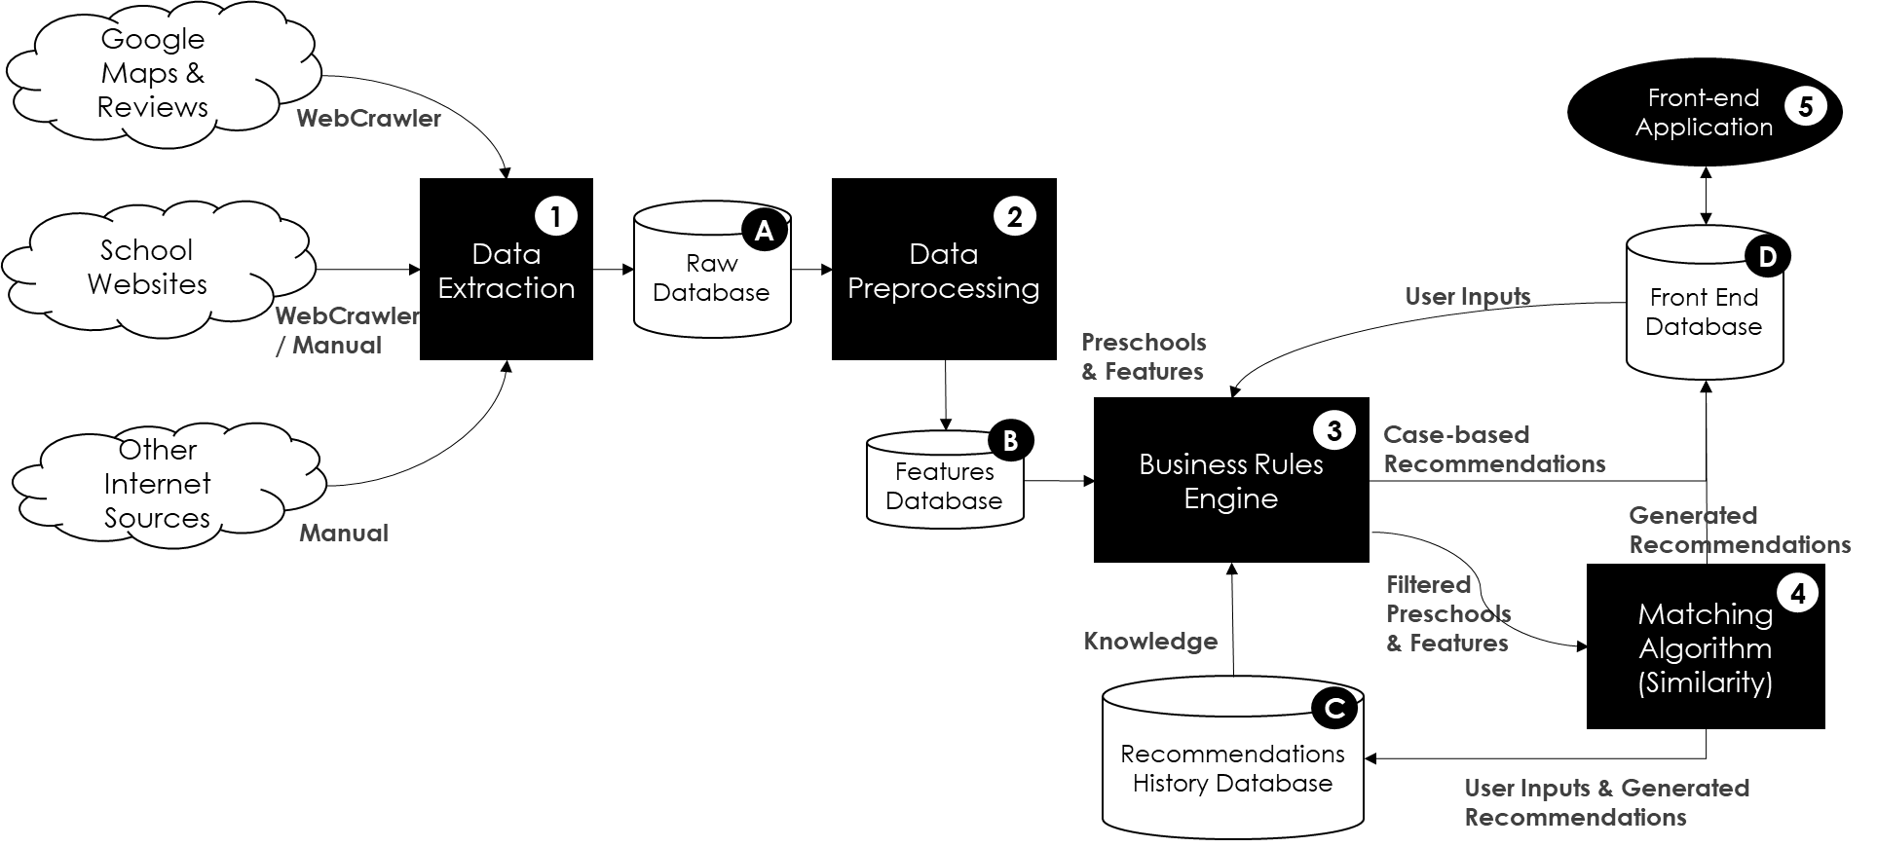

Figure : High Level System Design Map

**System design in GitHub folder structure:**

* Preschool Recommender
  + Documentations
    - Images
  + Resources
    - Google Maps [A]
    - SchoolPages [A] [B]
    - ProcessedGoogleMaps [B]
    - BusinessRulesEngine [C]
    - MatchingAlgorithm [C]
    - Front End [D]
  + Scripts
    - BusinessRuleEngine.py [3]
    - extract_combined_from_school_page_source_github.py [1]
    - MatchingAlgorithm.py [4]
    - Processor_GoogleMaps.py [2]
    - Processor_GoogleMaps_Reviews.py [2]
    - use_fees_to_replace_level_combined_csv.py [2]
    - Webcrawler_GoogleMaps_Functions.py [1]
    - Webcrawler_GoogleMaps_Refresh.py [1]
    - Webcrawler_GoogleMaps_Search.py [1]
    - Webcrawler_SchoolWebsites_Functions.py [1]
    - Webcrawler_SchoolWebsites_Refresh.py [1]
    - Webcrawler_SchoolWebsites_Search.py [1]
    - SG-Preschool Recommender.py [5]
  + SG-Preschool_Recommender.7z
* README.md

Figure : Project Structure within GitHub folder

**Detailed explanation on System Design Map:**

The raw database is a combination of web scraped data from google maps, school websites and internet school sources. These data are processed with one hot encoding and saved into a features database to be utilised by the business rules engine. The business rules engine has two functions. First it will check whether the current user preferences input matches any previous inputs in its history. Secondly, it contains the business rule logic to filter out cases that do not match the user input requirements. If user input does not match any previous input, the system will trigger business rules to filtered relevant preschools, before it passes on the filtered school list to the algorithm matcher in the matching folder. The final recommendation is finally output to user on the application page.

### Dataflow Diagram

In the data flow diagram, parents will access the front-end recommender application. They will input their user preferences for a preschool on the front-end interface. This will first match the user preference with a user history database to identify any exact similar queries.

If yes, it will retrieve the previously generated output from the knowledge base to recommend to the user, to speed up processing time. If no match is found, then it will proceed to the next step.

Next, the data will retrieve all preschool records in a consolidated preschool database. On these records, the business rule engine will first filter out records that immediately does not satisfy the constraints.

Next, the system will put the remaining preschools through a similarity algorithm to rank the closest match to the user input (based on curriculum, programme, rating factors etc). Finally, the top 3 closest match by 3 distinct school brand will be output to parent as a front-end recommendation.

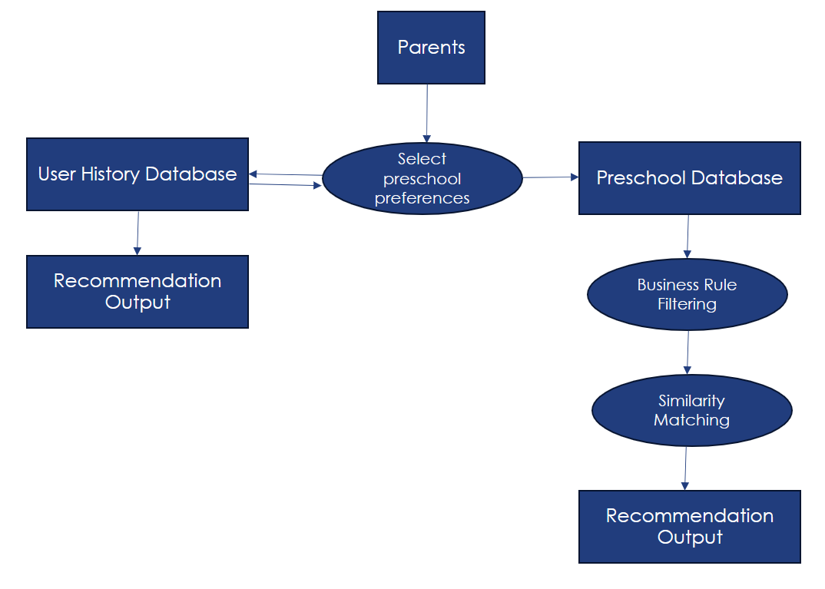

Figure 3: Data Flow diagram

### Tools & Technologies Used

This is the list of libraries used in the system.

|  |  |
| --- | --- |
| **Library** | **Function** |
| Pandas | Enable processing of vectors and CSV to manipulate data |
| Selenium | Web scraping library to simulate user entering a website |
| Beautiful Soup | Parsing library to extract webscraped information |
| Re (regex) | Regular expression library to search and match word patterns |
| OS | Read directory or file in the operating system |
| Llama | An open-source large language model to automate tag extraction for data collection. |
| Math | Used to manipulate numbers |
| Datetime | Used to manipulate date and time. |
| sklearn.preprocessing (MinMaxScaler) | Normalise data |
| sklearn.metrics.pairwise (cosine_similarity) | Calculate cosine similarity |
| scipy.spatial (distance) | Calculate Euclidean Distance and Manhattan Distance |
| spacy | An open-source Python library for Natural Language Processing. Used to process google reviews. |
| spacy.matcher (Matcher) | A component of spaCy used for rule-based matching of words and phrases within text document. Used to process google reviews. |
| gensim.downloader | A module in the Gensim library that provides an API for downloading, getting information, and loading pre-trained models and datasets. Used to process google reviews. |
| sklearn.feature_extraction.text (CountVectorizer) | A part of the Scikit-learn library, used for converting a collection of text documents to a matrix of token counts. |
| sklearn.decomposition (LatentDirichletAllocation) | A module in Scikit-learn that provides matrix factorization and other types of decomposition methods, useful for reducing dimensionality and discovering latent variables in data. Used for topic modelling. |
| textblob (TextBlob) | A Python library for processing textual data. Used for sentiment analysis in system. |

Table 6: List of libraries in system

This is the list of technologies used in the system.

|  |  |
| --- | --- |
| **Technology** | **Function** |
| Python | Programming language of the system for front end, reasoning, recommending and data processing functions. |
| VSCode | Integrated developer platform for coding scripts and saving files |
| GitHub | Source code repository and sharing platform |
| Pytkinter | Application building tool to output a graphic user interface |
| Jupyter Notebook | Write code and view results. Support functions for data processing |

Table 7: List of technologies in system

### Software Architecture Design

The intended design of the software architecture is to build a microservices architecture whereby each application is independent with its own responsibilities. In total, there are 8 applications in the architecture.

1. 1x front-end application: To host the user interface for all presentations and interaction with the users.
2. 2x data collection application:
   1. 1x application to pull the data from google maps & reviews periodically
   2. 1x application to pull the data from a list of pre-school websites periodically
3. 3 x data processing application:
   1. 1x application to process the data from google maps
   2. 1x application to process the data from google reviews and run the sentiment analysis & topic modelling algorithm
   3. 1x application to process the data coming from pre-school websites
4. 1x business rules engine: To process the business rules and return the results to either front-end application or matching algorithm.
5. 1x matching algorithm: To run the similarity metric and return the results to the front-end application.

However, for the MVP, the intent is to prototype the solution quickly without incurring unnecessary cost in implementing a microservices architecture. The following modifications are made in the software architecture:

1. Instead of implementing an API call to communicate among the various applications, a flat file is used for the data transfer and the applications are manually triggered for the data collection and data processing. The downside is that this is not fully automated but will suffice with static data for the prototype.
2. For the business rules engine and matching algorithm, they are combined with the front-end application by calling the class objects. While they are combined in the MVP, this can be easily split out into individual application.

## Data Collection

### Data Sources

|  |  |
| --- | --- |
| **Information Type** | **Sources** |
| Pre-school Information | * Pre-school Official Websites (e.g., MapleBear, MindChamps, My First Skool, etc.) * Preschool Certifications (e.g, spark-certified-centres_2jan2024.pdf (ecda.gov.sg)) * Competitors’ website (e.g., Skoolopedia , preschooler) * Google Maps |
| Pre-school Reviews | * Google Reviews |
| Criteria looked out by parents in pre-school selection | * Traditional Media (e.g., commentary sections) * Information learnt through interviews with parents |

Table 8: List of technologies in system

### Google Maps & Reviews

Google Maps is a single page application which does not load the full html page unless being navigated to. To overcome this, Selenium & Chrome driver are used to automatically navigate to the website and specifically to the relevant information by clicking on buttons and scrolling down. In addition, Beautiful Soup is used to find the specific html element to retrieve the target text such as location, opening hours, reviews, ratings.

As the search is based on an initial list of SPARK Certified pre-schools from ECDA (Early Childhood Development Agency) and does not always return an exact hit in the search, the application also conducts an expansive search by looping through all the search results even though it is not in the initial list. However, such an expansive search can return childcare out of Singapore or other type of establishments. Therefore, a manual curation of the list is needed.

To ensure that the curated list is updated, the application can do an automatic refresh periodically on the curated list of pre-schools. This function is kept separated from the expansive search function.

### Preschool Websites

The starting point for preschool websites is based on the website links extracted from Google Maps during the web crawling. The website links are navigated to using the Selenium & Chrome driver and any links on these websites are then further extracted for a deeper web crawling. After navigation, the pages are then being saved as a file for processing later.

While the automatic extraction works, the results are not complete such as missing fees information that is segregated by Singapore Citizens, Permanent Residents and by educational level (i.e., infant-care, playgroup, nursery, kindergarten). To supplement the information, leveraging on large language model for data collection is first considered but is unsuccessful due to unpredictable formats of publishing pre-school fee information. Eventually, manual extraction of the fee information is done to overcome the data collection challenge.

## Data Processing

This section summarises the features collected from online sources to be used as the preschool variables in the data analysis.

Mainly, the collected features are from Google Maps & Google Reviews and Preschool sites. The Google Maps information include Average Star Ratings, User Review Topics, Opening Days, Opening Hours, Site Update Timestamp, Location, Latitude, Longitude, User Reviews. The Preschool Sites information contain Fees, Curriculum, Program, Levels.

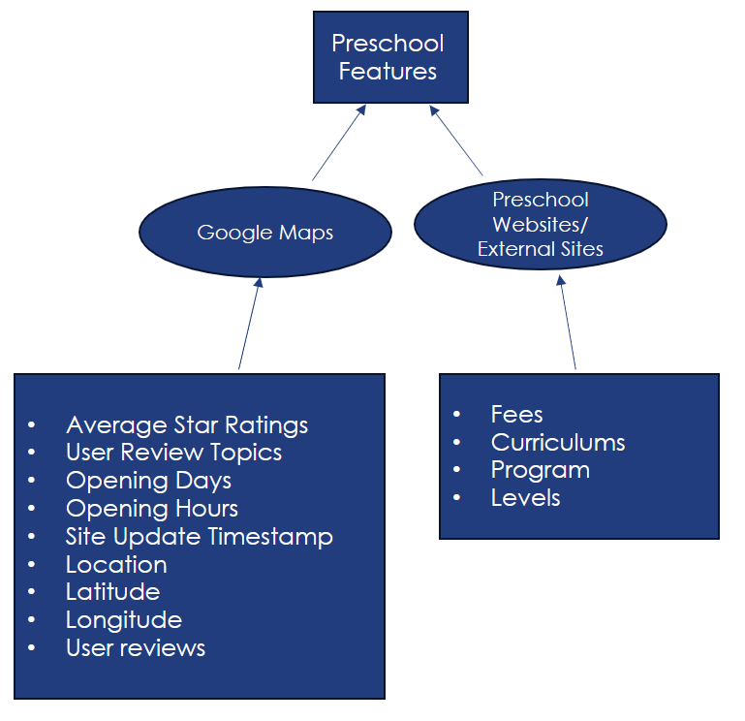

Figure 4: Data collected to be utilised for preschool features

### Google Maps

In general, regex is used to clean the unwanted data collected. For the operating hours, regex is further used to process and split up the operating hours into individual days and opening & closing hours. This is to ensure that the timing constraints can be easily factored in during the processing by the business rules engine. Likewise for the latitude and longitude, regex is used to extract them out separately for processing later by the business rules engine.

### Google Reviews

To process the google reviews, there are 4 steps being done:

1. Text pre-processing (stop-words removal, punctuation removal, lemmatisation, replace abbreviation, non-alphabet word removal) using Spacy, Regex and word2vec models to process the words for subsequent processing
2. Topic modelling using Latent Dirichlet Allocation (LDA) to determine the topics and top 20 key words from the reviews
3. Sentiment analysis using TextBlob to look at the polarity of the sentiments to assign a score between –1 to 1
4. Large language model (ChatGPT) to make sense of the topics

Topic modelling is first performed at the aggregated level across all reviews to derive the topics and top 20 keywords. Thereafter, a topic is assigned to each review with the sentiment analysis performed at the same time. At this step, every review is now having a sentiment score and a topic assigned to it. To derive the scores by topic for each pre-school, the sentiment score is averaged across all reviews by school.

By controlling the hyperparameter of number of topics, the LDA model is run from 2 to 10 topics. 6 topics are eventually chosen based on measuring the density (non-zeros) of the sentiment scores by topic by pre-school.

|  |  |  |  |  |  |  |  |  |  |  |
| --- | --- | --- | --- | --- | --- | --- | --- | --- | --- | --- |
| **n_topics** | **Topic_0_Blank** | **Topic_1_Blank** | **Topic_2_Blank** | **Topic_3_Blank** | **Topic_4_Blank** | **Topic_5_Blank** | **Topic_6_Blank** | **Topic_7_Blank** | **Topic_8_Blank** | **Topic_9_Blank** |
| 2 | 25.8% | 16.3% |  |  |  |  |  |  |  |  |
| 3 | 23.4% | 11.5% | 90.4% |  |  |  |  |  |  |  |
| 4 | 20.4% | 11.3% | 90.4% | 95.6% |  |  |  |  |  |  |
| 5 | 18.3% | 9.8% | 90.4% | 95.2% | 95.9% |  |  |  |  |  |
| 6 | 17.4% | 9.5% | 90.4% | 95.0% | 94.8% | 8.7% |  |  |  |  |
| 7 | 17.2% | 9.4% | 90.4% | 94.8% | 94.5% | 7.5% | 99.6% |  |  |  |
| 8 | 16.5% | 9.2% | 90.4% | 94.8% | 94.0% | 6.7% | 98.9% | 99.1% |  |  |
| 9 | 16.3% | 9.2% | 90.4% | 94.5% | 94.0% | 5.8% | 98.4% | 99.0% | 80.0% |  |
| 10 | 16.2% | 9.1% | 90.4% | 94.5% | 93.5% | 4.7% | 98.3% | 96.7% | 77.7% | 99.7% |

Table 9: Chart of density of sentiment scores by topic by preschool

**Legend:** % above reflects the % of blank values for the topic. The higher the %, the more sparse (more blank) the topic contains.

### Preschool Websites

Using the txt page sources extracted, Beautiful Soup is first employed for parsing and extracting structured data like curriculum, programs, and levels from school websites.

However, due to the immense number of preschool programmes and curriculum, a LLM is utilised to classify the common programme tags and curriculum tag through LLM prompt instructions.

The Jupyter notebook code for doing tag classification for curriculum and programmes respectively can be found in GitHub folder

>> Github Folder: Preschool_Recommender/scripts/llm_webscrap_preschool_curriculum

>> Github Folder: Preschool_Recommender/scripts/llm_webscrap_preschool_programmes

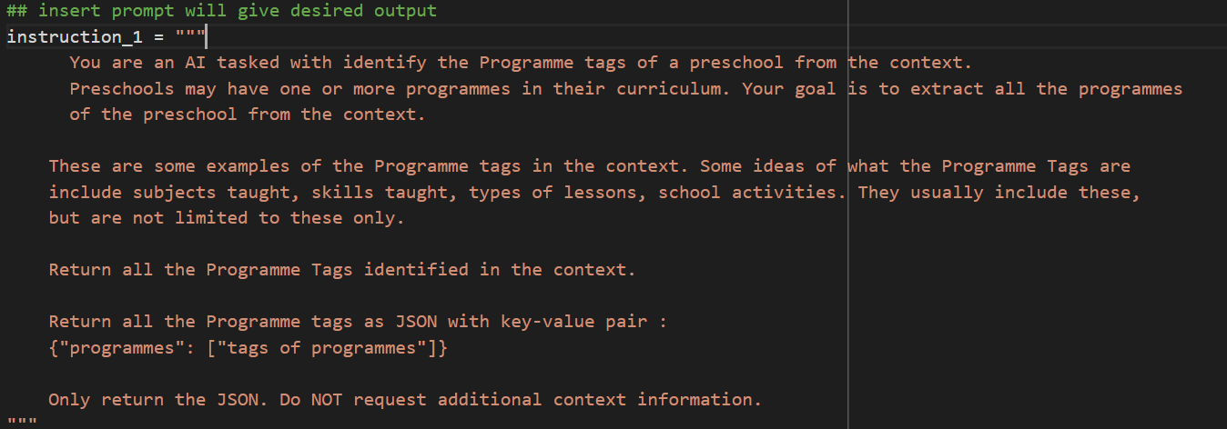

Figure 5: LLM prompt to identify Programme tags from webscraped preschool information

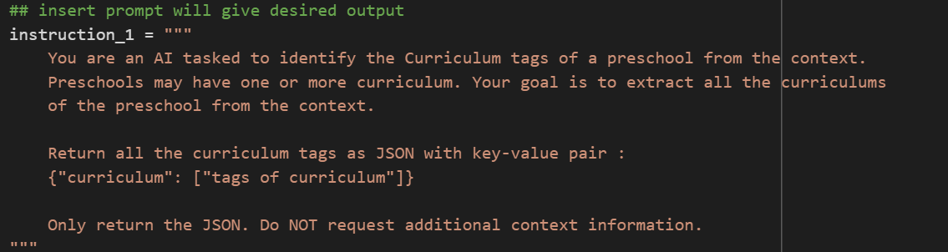

Figure 6: LLM prompt to identify curriculum tags from webscraped preschool information

After the relevant programme and curriculum tags are identified, regex is employed to match all txt files for a single preschool. The regex would classify a school to offer English as one of its programmes if any of the relevant tags are found, example literacy, English language etc.

## Business Rules Engine

On a high level, the business rules engine performs five key steps.

1. It searches the previous user search history to check for exact match against the user inputs (*see case-based reasoning*).

Where there is no match from Step 1,

1. The processed data of Google Maps and preschool websites from the preceding steps is first consolidated.
2. As the inputs provided by the user are locations (represented by latitude and longitude), a crow-fly distance is calculated against all the schools to derive the distance of each school to the user's selected location. *(see distance calculation)*
3. Based on distance, opening hours, and budget constraints provided by the user, the list of preschools that qualify is returned and sent to the matching algorithm. *(see constraint filtering)*

### Case-based Reasoning

Case-based reasoning (CBR) helps to facilitate more efficient processing. This function operates by comparing the user's input preferences for preschools with existing cases stored in a user history database. When a new query is made by a parent accessing the recommender application, CBR conducts a search for exact matches in user history data. If a match is found, the system retrieves the corresponding recommendation from the knowledge base, bypassing the need for redundant processing. This approach aims to reduce processing time and improve recommendation efficiency.

CBR improves the speed and efficiency of the reasoning system processes. By leveraging past interactions and outcomes, the system adapts to user preferences and optimizes the recommendation process. Moreover, CBR exemplifies intelligent functionality by emulating human-like reasoning capabilities. This process identifies a need whether to proceed to more detailed step of knowledge discovery, to prevent duplication of work (automating the reasoning function). Case based reasoning allows the system to adapt to different user input preferences and form an important function of the recommender.

### Distance Calculation

Distance filtering is designed to refine preschool options based on the proximity to the user's selected location. This function operates by employing business rules that incorporate crow-fly distance calculation. Thus, the first step is to calculate the distance between the user selected location and the preschools.

Based on the Pythagorean theorem, the formula for calculating the distance between two points as the crow flies is distance = √((x2 - x1)^2 + (y2 - y1)^2), where X1, Y1 and X2, Y2 are the Cartesian coordinates of the destinations.

The business rules engine retrieves all preschool records from the consolidated database and assesses their geographic coordinates relative to the user's location. It then determines the distance between each preschool and the user's specified location using the crow-fly distance calculation.

### Constraint Filtering

Based on the distance, opening hours, and budget constraints, the business rules engine filters out preschool rows with respective values that exceed the specified range. By proactively adapting to user preferences and constraints, the system optimizes the preschool selection process.

#### Distance Filtering

Distance filtering ensures that only preschools within the user's desired proximity are used for consideration to provide more tailored results for users. This not only optimises decision-making for users but also enhances the overall user experience by presenting options that are geographically convenient. Ultimately, distance filtering increases the system's intelligence by considering both user preferences and geographical factors, which effectively customise recommendations to user’s needs.

#### Budget Filtering

The budget filtering mechanism operates by applying predefined budget constraints to the entire dataset of preschool records retrieved from the consolidated database. Specifically, the business rule engine initiates the filtration process by excluding records that do not meet the user's specified budget requirement. By eliminating preschool options that exceed the user's financial constraints upfront, the system streamlines decision making as a recommender.

The integration of budget filtering is an intelligent function within the recommender system due to its ability to dynamically adapt to user preferences and constraints. Rather than presenting users with a vast array of options that may not align with their budgetary requirements, this business case reasoning narrows down the available choices to those that fulfil financial constraint. This proactive approach not only saves users time and effort but also demonstrates the system's capacity to analyse and prioritize information based on contextual parameters. By leveraging filtering techniques, to reflect business rules, the system ensures that recommendations are tailored to the user's specific needs, which improves effectiveness of recommendation system.

#### Operating Hours Filtering

Different parents have different needs to when they need to pick up or drop-off the children to fit their busy working schedules. Therefore, operating hours of preschool is important to be determined against their needs. Often, these are non-negotiable. The business rule engine thus takes the inputs provided by the user and check against all the preschools to understand if the operating hours of the preschool from Monday to Sunday is within the consideration of the user when performing the filtering.

As the user does not always need preschool services, for example, on Saturday and Sunday, even though the preschool is open, the business rule engine introduces a logic to ignore such use cases when evaluating the user inputs.

## Matching Algorithm

The Matching Algorithm is an essential component within the intelligent system recommender, tasked with identifying the most suitable preschool options based on user input. This algorithm utilises cosine similarity to assess similarity between the user's preferences and the characteristics of each preschool in the dataset. By analysing factors such as curriculum, programs offered, ratings from reviews, distance, price, the Matching Algorithm ranks preschool with the highest similarity, compared to the user input preferences. Finally, the top three closest matches are outputted to the parent as recommendations via the front-end interface.

The necessity of the Matching Algorithm lies in its ability to streamline the decision-making process for parents seeking preschool options. By employing cosine similarity calculations, the algorithm intelligently compares user preferences with the attributes of preschools, to identify the most relevant options. Moreover, the algorithm's deductive search approach ensures that recommendations are tailored to the specific needs and preferences of the user, displaying intelligent function in the system and allowing for personalisation to user preschool preferences.

### Model Data

The model contains the following categories of data that are used in the similarity metric calculation.

|  |  |  |
| --- | --- | --- |
| Data Domain | Data Fields | Data Type |
| Distance | Distance_To_User_km  Note: Distance are being recalculated against the user selected locations. | Continuous  (Normalised) |
| Budget | fees_sc_infant_care, fees_sc_playgroup, fees_sc_nursery, fees_sc_kindergarten, fees_pr_infant_care, fees_pr_playgroup, fees_pr_nursery, fees_pr_kindergarten  Note: Only 1 fee type is being used at each time, depending on the user input. | Continuous  (Normalised) |
| User Reviews | Average_Stars, Topic_0, Topic_1, Topic_2, Topic_3, Topic_4, Topic_5  Note: Topic 1 to Topic 5 represents the sentiment analysis based on the comments given by the users. | Continuous  (Normalised) |
| Curriculum | curriculum_active_learning, curriculum_bilingual_curriculum,  curriculum_child_directed, curriculum_chinese_curriculum,  curriculum_early_years_development_framework,  curriculum_english_curriculum,  curriculum_ib_pyp,  curriculum_inquiry_based,  curriculum_integrated_curriculum,  curriculum_montessori,  curriculum_moe,  curriculum_nurturing_early_learners_curriculum,  curriculum_play_based_curriculum,  curriculum_project_based,  curriculum_reggio_emilia_approach,  curriculum_spark_certified_curriculum,  curriculum_thematic,  curriculum_isteam | Categorical  (One-hot encoded - Binary) |
| Programme | programme_aesthetics_&_creative_expression, programme_chinese, programme_digital_skills,  programme_discovery_of_the_word, programme_english, programme_language_and_literacy, programme_math, programme_moral_education, programme_motor_skill_development, programme_music, programme_nature, programme_numeracy, programme_problem-solving_skills, programme_project_work,  programme_science, programme_sensory_play, programme_social_&_emotional_development, programme_speech_and_drama, programme_sports | Categorical  (One-hot encoded - Binary) |

Table 10: Categories of Data used for Similarity calculation

To further understand the continuous (normalised data), the following charts are plotted to observe the distribution. The observations are:

1. Distance and sentiment analysis by topics generally follow a gaussian distribution.
2. Average stars, which are rating given by the google users, follow an exponential distribution.
3. Preschool fees generally follow a unimodal distribution due to the domination of certain preschool brands.

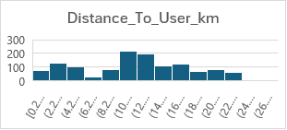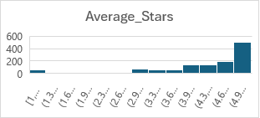

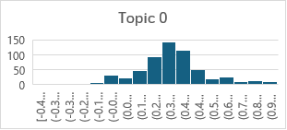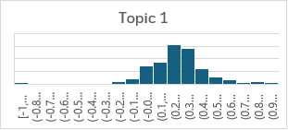

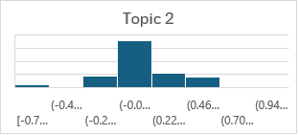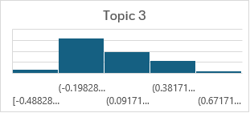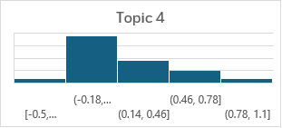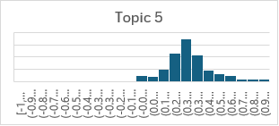

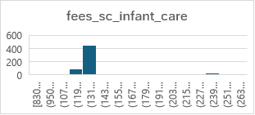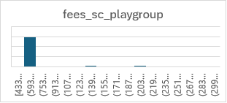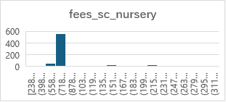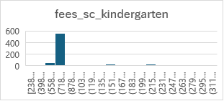

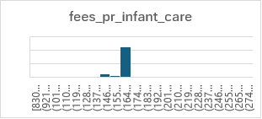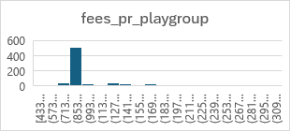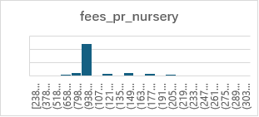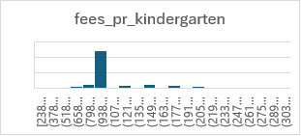

Figure 7: Histogram of distribution of data variables (variable name found in title of histogram)

Next, each feature of the model is evaluated for linear correlation against each other. The observations are that in general, only 8% of the permutations observe a strong correlation of >0.75. This leads to the conclusion that the features amongst the model is not strongly linear correlated.



### Considerations in Shortlisting Similarity Metrics

7 similarity metrics are considered in the evaluation.

|  |  |
| --- | --- |
| **Similarity Metrics** | **Explanation** |
| Pearson Correlation | This measures the linear correlation between two variables. It’s useful when you want to find out if there are any linear relationships between variables. |
| Spearman’s Rank Correlation | This is a non-parametric test that is used to measure the degree of association between two variables. It’s useful when you want to find out if there are any monotonic relationships between variables. |
| Jaccard Similarity | This measures the similarity between finite sample sets and is defined as the size of the intersection divided by the size of the union of the sample sets. It’s often used for comparing the similarity of sample sets. |
| Hamming Distance | This measures the minimum number of substitutions required to change one string into the other, or the minimum number of errors that could have transformed one string into the other. It’s often used in computer science for comparing strings. |
| Euclidean Distance | This is the straight-line distance between two points in a space. It’s useful when your data is dense or continuous. |
| Manhattan Distance | Also known as city block distance, it is the sum of the absolute differences of their coordinates. It’s useful when you want to calculate the distance in a grid-based system. |
| Cosine Similarity | This measures the similarity between two vectors of an inner product space. It is measured by the cosine of the angle between two vectors and determines whether two vectors are pointing in roughly the same direction. |

Table 11: Description of 7 alternative similarity metrics

In evaluating the performance of different similarity metrics for the recommender system, the following factors are considered:

1. Suitability, a measure of how appropriate the metric is given the model data distribution and purpose of metric.
2. Serendipity, a measure of how surprising the successful recommendations are.
3. Diversity, a measure of how different the recommendations are from one another.
4. Performance, a measure of user feedback on the usefulness of the recommendations.

#### Suitability

Pearson correlation and Spearman's rank correlation are effective for measuring linear and monotonic relationships, respectively. However, they are eliminated first as the linear correlation amongst the model data is not strong. Pearson Correlation and Spearman’s Rank Correlation’s effectiveness will thus be ineffective given that it might lead to overfitting when used.

Jaccard similarity, useful for comparing finite sample sets, and Hamming distance, suitable for comparing strings, are subsequently eliminated as the data contains multiple distributions from (Gaussian, exponential, unimodal, binomial /binary).

Euclidean distance, Manhattan distance and Cosine Similarity are hence potential similarity metric candidates for the matching algorithm. This is despite Euclidean distance and Manhattan distance being limited in effectiveness, under scenarios when data is high-dimensional or sparse.

#### Serendipity, Diversity & Performance

To ascertain the serendipity, diversity & performance, the model has to be contextualised to actual users for relevance. Therefore, test users are invited to test the model and feedback is also gathered from them regarding how surprising, diverse and useful the recommendations are. For illustration of the findings, 2 user profiles are picked, and their results are shared below.

**Profile #1**

* Drop-off Timing of Mon to Fri, 8am
* Pick-up Timing of Mon to Fri, 6pm
* Budget of S$1,500 per month
* Prefers Inquiry Based Integrated and Montessori programs
* Prefers English program
* Lives in Bukit Batok Central, Singapore 659958
* Willing to travel up to 5km (crow-fly)

The top 3 ranked results are as follows:

|  |  |  |  |  |  |  |
| --- | --- | --- | --- | --- | --- | --- |
| **Rank** | **Cosine Similarity** | **Value** | **Euclidean Distance** | **Value** | **Manhattan Distance** | **Value** |
| 1 | Ace @ Work Childcare Pte Ltd | 0.292 | Sunflower Preschool @ West Rock Pte Ltd | 4.00 | Sunflower Preschool @ West Rock Pte Ltd | 16.3 |
| 2 | Seventh-day Adventist Conference (Singapore) - Adventist Schoolhouse | 0.288 | Sunflower Preschool @ West Terra Pte Ltd | 4.08 | Sunflower Preschool @ West Terra Pte Ltd | 16.9 |
| 3 | Spring Brainy Kidz (Bukit Batok) Pte Ltd | 0.275 | Ace @ Work Childcare Pte Ltd | 4.78 | Sunflower Preschool @ Mindef (Gombak) Pte Ltd | 17.7 |

Table 12: Similarity result scores based on Parent Profile 1

**Profile #2**

* Level: Playgroup
* Drop-off Timing of Mon to Fri, 8am
* Pick-up Timing of Mon to Fri, 6pm
* Budget of S$2,500 per month
* Prefers Speech & Drama, Sports programs
* No preference on curriculum
* Lives in Khatib, near to the MRT station
* Willing to travel up to 2km (crow-fly)

The top 3 ranked results are as follows:

|  |  |  |  |  |  |  |
| --- | --- | --- | --- | --- | --- | --- |
| **Rank** | **Cosine Similarity** | **Value** | **Euclidean Distance** | **Value** | **Manhattan Distance** | **Value** |
| 1 | NurtureStars Pte Ltd (SAFRA Yishun Country Club) | 0.265 | NurtureStars Pte Ltd (SAFRA Yishun Country Club) | 4.672 | NurtureStars Pte Ltd (SAFRA Yishun Country Club) | 22.991 |
| 2 | Skool4Kidz Centre (Yishun Orchid Spring) | 0.204 | The Orange Academy (Yishun) Pte Ltd | 4.938 | The Orange Academy (Yishun) Pte Ltd | 24.774 |
| 3 | Skool4Kidz Centre (Yishun Oleander Breeze) | 0.203 | PPS Yishun | 4.980 | PPS Yishun | 25.718 |

Table 13: Similarity result scores based on Parent Profile 2

The first observation of the results is that Cosine Similarity produces a different top 3 recommendations from Euclidean Distance and Manhattan Distance and, Euclidean Distance and Manhattan Distance largely produce the same top 2 results.

The second observation of the results is that the diversity of the results is heavily dependent on the preschools that passes the various constraints during filtering. This is turn also affects negatively on the assessment of serendipity as the preschools recommended are largely limited by its location. This is common across all 3 similarity metrics.

Another observation relating to diversity and serendipity is that the tendency of whether the recommendations would converge to a certain school brand based on each similarity metric is not conclusive.

Apart from the actual results, feedback is also gathered from the test users to establish the usefulness of the recommendations through interviews. An observation on the feedback is that the recommendations are useful for first-time parents whereby it helps to speed up the search. However, for parents who have more than one child, the results may not be as useful. Another observation is that diversity of the school brands is key in influencing the usefulness of the recommendations.

### Cosine Similarity as the Chosen Similarity Metric

Based on the evaluations above, cosine similarity is chosen as the metric to be used because of the following reasons.

Firstly, it performs better in terms of diversity and serendipity of school brands which is key component of what users are looking for in the recommender.

Secondly, the Cosine Similarity calculation quantifies the similarity between vectors of input variables, ranging from fees to reviews. Unlike other similarity metrics, cosine similarity is particularly adept at handling varying magnitudes in variables because it primarily considers the angle between vectors rather than their magnitudes. In this context whereby the data are predominantly categorical and high-dimensional, cosine similarity ensures that the continuous data do not dominate the model and is more capable to handle the large number of features.

In summary, the above makes Cosine Similarity a robust and versatile tool for similarity matching, ensuring that recommendations are based on the relative alignment of user preferences and the attributes of available options rather than absolute values. This thereby enhances the relevance and practicality of the suggestions provided.

## Front-End Application

Given the limitation of the cosine similarity in achieving diversity and serendipity of school brands consistently, the front-end application applies a logic to ensure that the top 3 results will always be from a different school brand. This is despite that it might not be ranking in the top 3 solely based on the similarity score.

# Future Improvements

Given that the project is to deliver a minimum viable product (MVP) to test out the suitability of the features used and the usefulness of the model recommendations to the target user group, the features demonstrated are sufficient to start gathering the initial feedback. As a comprehensive user research demands more time, cost, and effort in acquiring user and testing with them, this cannot be attained during this MVP. Also, given that this is an MVP, the data collected is also limited in its accuracy and availability, and is only based on a snapshot point in time.

Therefore, in the future improvements / subsequent iterations of the system, more can be done to (1) listen to user feedback and improve upon similarity model to give better recommendations, and (2) improve the data availability, accuracy and timeliness.

## System Features Improvement

To improve the reliance of users on the system, the following features can be built.

1. Integration of user reviews and ratings to provide social proof and enhance decision-making for parents.
2. Provision of virtual tours or informative images of preschool facilities, giving parents a better sense of the environment.
3. Refinement of features that are critical to parents’ selection of preschools.

## Data Availability, Accuracy and Timeliness Improvement

To improve the performance of the recommender, the first will be to tackle the data availability, accuracy, and completeness. To do this, the system will need to:

1. **Data Availability:** Make use of image recognition to enrich the existing data by including preschools’ amenities data such as play area, learning monitors etc.
2. **Data Accuracy:** Minimise the missing information gap by leveraging on user feedback and preschool partnerships to ensure the most up-to-date information for users.
3. **Data Timeliness:** Data Automate the retrieval of preschool information through deploying the existing scripts on a cloud architecture.

## Model Improvement

With more users’ preferences and feedback on the recommendations gathered through the MVP, collaborative filtering can be built into the model to enhance the performance of the model. This will also help to resolve the diversity and serendipity feedback collected during the MVP as users can be recommended preschools based on similarity to other users.

# Conclusion

The preschool recommender site offers personalized recommendations based on user preferences, enhancing the preschool selection process for parents. This application will provide a digital transformation in the preschool selection space by automating the decision-making process. This transforms the current ways of manually researching for information and ploughing through the multitude of information to get what is truly necessary for deciding on a preschool.

In this report, we discuss on the methodology and system design to build the recommender and how we overcame the technical limitations during the data collection and processing. We also discuss the trade-offs made in deciding on the suitable similarity metrics for such a system. Lastly, we look towards the future as we plan the possible future improvements that can be made to the system to enhance the performance and relevance of the recommender to the target user group.

# References

## Citations

* 2024. SPARK (Commendation) Certification. https://www.ecda.gov.sg/docs/default-source/default-document-library/spark-certified-centres_26feb2024.pdf?sfvrsn=79be6e1f_3.
* n.d. ChatGPT. Accessed April 15, 2024. https://chat.openai.com/.
* n.d. Microsoft Copilot: Your everyday AI companion. Accessed April 15, 2024. https://copilot.microsoft.com/.
* Begum, Yasmin. 2023. 7 things to consider when choosing a preschool, from location to licence tenure. CNA. https://www.channelnewsasia.com/singapore/choosing-preschool-what-look-out-tips-advice-3749441.
* ECDA | Choosing a preschool for your child. 2023. Early Childhood Development Agency (ECDA). https://www.ecda.gov.sg/parents/choosing-a-preschool/choosing-a-preschool-for-your-child.
* Great Learning. 2024. Introduction to NLP. Introduction to Natural Language Processing. https://www.mygreatlearning.com/academy/learn-for-free/courses/introduction-to-natural-language-processing.
* Image Creator from Microsoft Designer. n.d. Microsoft Copilot. Accessed April 26, 2024. https://copilot.microsoft.com/images/create.
* Ling, Nuria, and Renald Loh. 2023. How do parents pick the right preschool? Use head, heart and gut, say experts. Today Online. https://www.todayonline.com/singapore/how-pick-right-preschool-experts-2250981.
* NUS ISS and telescopeuser. 2017. Github. <https://github.com/IRS-PM/Workshop-Project-Submission-Template>.
* Sharni, Guy, and Asela Gunawardana. 2010. “Evaluating Recommendation Systems.” Springer, (October), 257–297. https://doi.org/10.1007/978-0-387-85820-3_8.
* Ting, Li, and Terence Ho. 2024. Commentary: How Budget 2024 sets out to tackle wage gaps and social mobility in Singapore. Today Online. <https://www.todayonline.com/commentary/commentary-how-budget-2024-sets-out-tackle-wage-gaps-and-social-mobility-singapore-2365576>.
* “tkinter — Python interface to Tcl/Tk — Python 3.12.3 documentation.” n.d. Python Docs. Accessed May 3, 2024. https://docs.python.org/3/library/tkinter.html.
* “What is a Data Flow Diagram.” n.d. Lucidchart. Accessed April 28, 2024. https://www.lucidchart.com/pages/data-flow-diagram.

# Appendix

## System Functionalities Against Course Content

|  |  |  |
| --- | --- | --- |
| **Requirement Group** | **Intelligent Reasoning Techniques** | **Module** |
| Decision automation: Business rules & process **OR** Knowledge based reasoning techniques | Rule-based reasoning   * Filtering based on constraints of attending preschool (e.g., budget, distance)   Case-based reasoning   * Retrieval of past recommendations based on matching current user inputs and previous user inputs | Reasoning Systems |
| Knowledge discovery & (big) data mining techniques | Analogical machine learning   * Clustering & finding similarity between user inputs and preschool features | Machine Reasoning |
| System designed with cognitive techniques or tools | Knowledge base   * Storing of previous recommendations as knowledge to be used for knowledge-based reasoning | Cognitive Systems |

## Installation Guide

### System Requirements

**Hardware Requirements**

* **Processor**: 64-bit processor with a minimum clock speed of 1 GHz. For better performance, a multi-core processor is recommended.
* **Memory**: At least 2 GB of RAM. For better performance, 4 GB or more is recommended.
* **Storage**: A minimum of 500 MB of free disk space.

**Software Requirements**

* Operating System==Windows
* Python==3.11

**Dependencies**

**(no installation required for dependencies)**

* beautifulsoup4==4.12.3
* ChecklistCombobox==1.1
* customtkinter==5.2.2
* gensim==4.3.2
* numpy==1.26.4
* pandas==2.2.2
* python_dateutil==2.8.2
* scikit_learn==1.4.0rc1
* scipy==1.13.0
* selenium==4.20.0
* spacy==3.7.4
* textblob==0.15.3
* tkcalendar==1.6.1
* tkintermapview==1.29

### Installation Instructions

* Step 1: Download the project repository from GitHub as ZIP file.

<https://github.com/ISS-IntelligentSystem-GroupProject24PT/Intelligent-Reasoning-System.git>

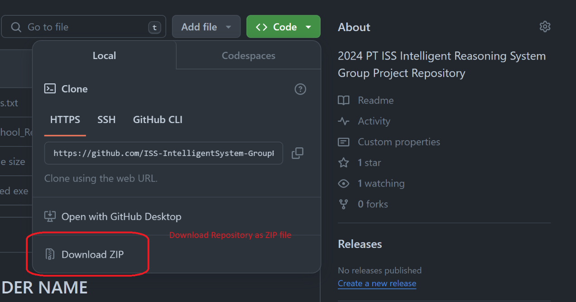

* Step 2: Extract zipped content.
* Step 3: Copy the “Preschool_Recommender” folder to the C:/ Drive.

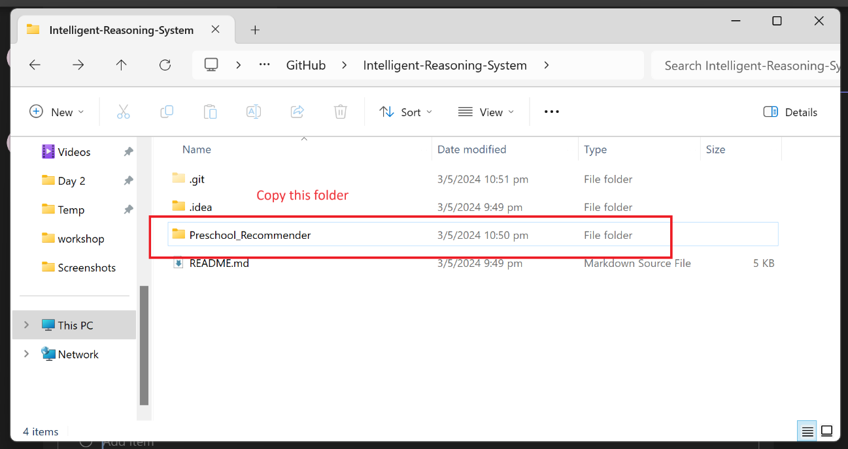

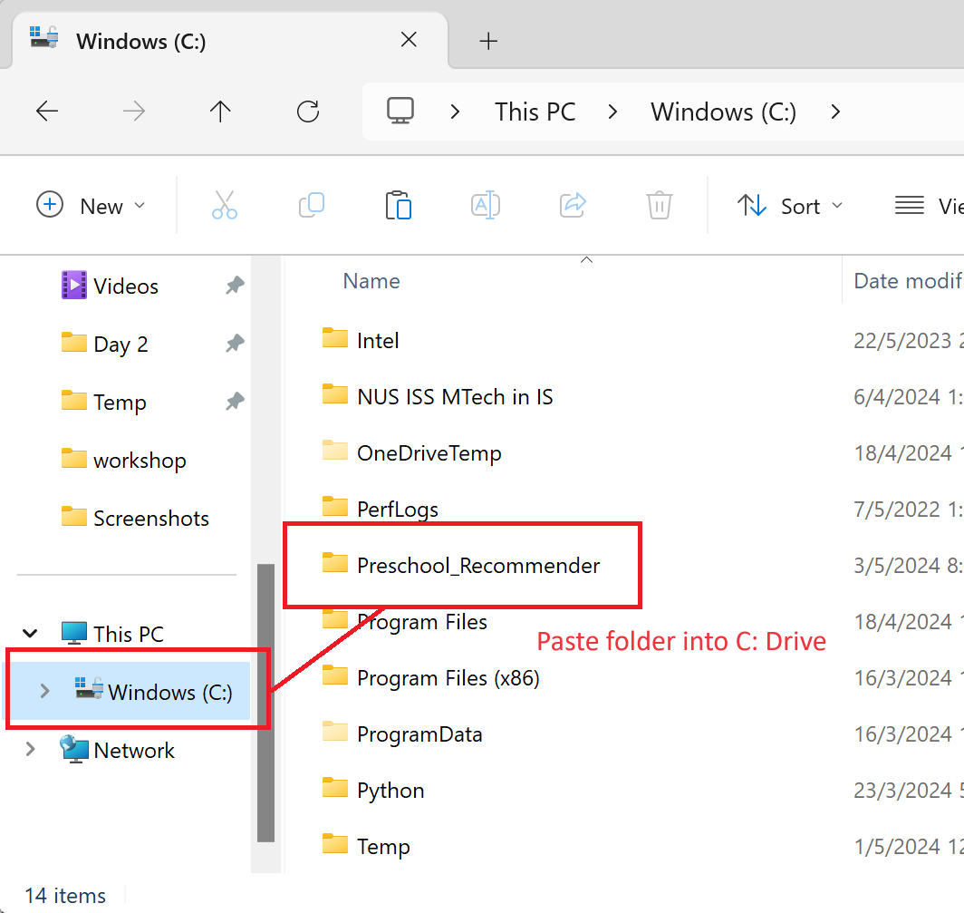

* Step 4: Open “Preschool_Recommender” folder and extract

“SG-Preschool_Recommender.7z” using “Extract here” option.

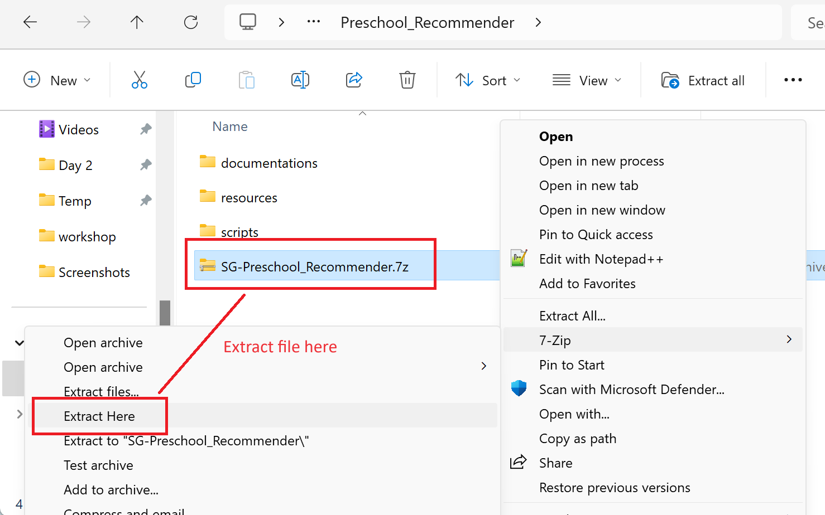

* Step 5: Your installation is done. SG-Preschool_Recommender application can now be executed by running the .EXE file.

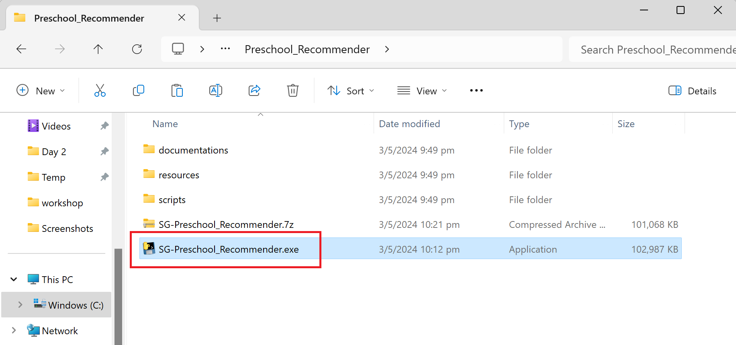

## User Guide

### Introduction

Welcome to the User Guide for SG Preschool Recommender. This guide is designed to provide you with all the information you need to get most out of our product. SG Preschool Recommender is a product that aims to help parents in search of a suitable pre-school for their children based on their needs, preferences, and constraints. The objective of the recommender system is to help parents speed up their research and decision for selecting a pre-school. This is especially pertinent in today’s world of exploding information on the internet such as in the online forums, pre-school websites, social media, parent groups.

### Getting Started

#### Accessing the Preschool Recommender

User can open the application easily by double clicking the SG-Preschool_Recommender.exe file once they finished installation.

#### Front Starting Page

User should be able to see below starting page after waiting for a short while. There are a couple of questions on the starting page that user needs to answer. These questions are specially designed based on research to let the system be more familiar with the user requirements and let the system be able to give recommendations closest to the user need. Only monthly budget is compulsory among all these questions. User can also click the Generate Results button directly after providing monthly budget. The default value used to generate results for location, preferred distance, citizenship status and child’s date of birth will be Yishun Ave 2, Singapore 769902, 1KM, Singaporean and Nov. 4th 2022 respectively.

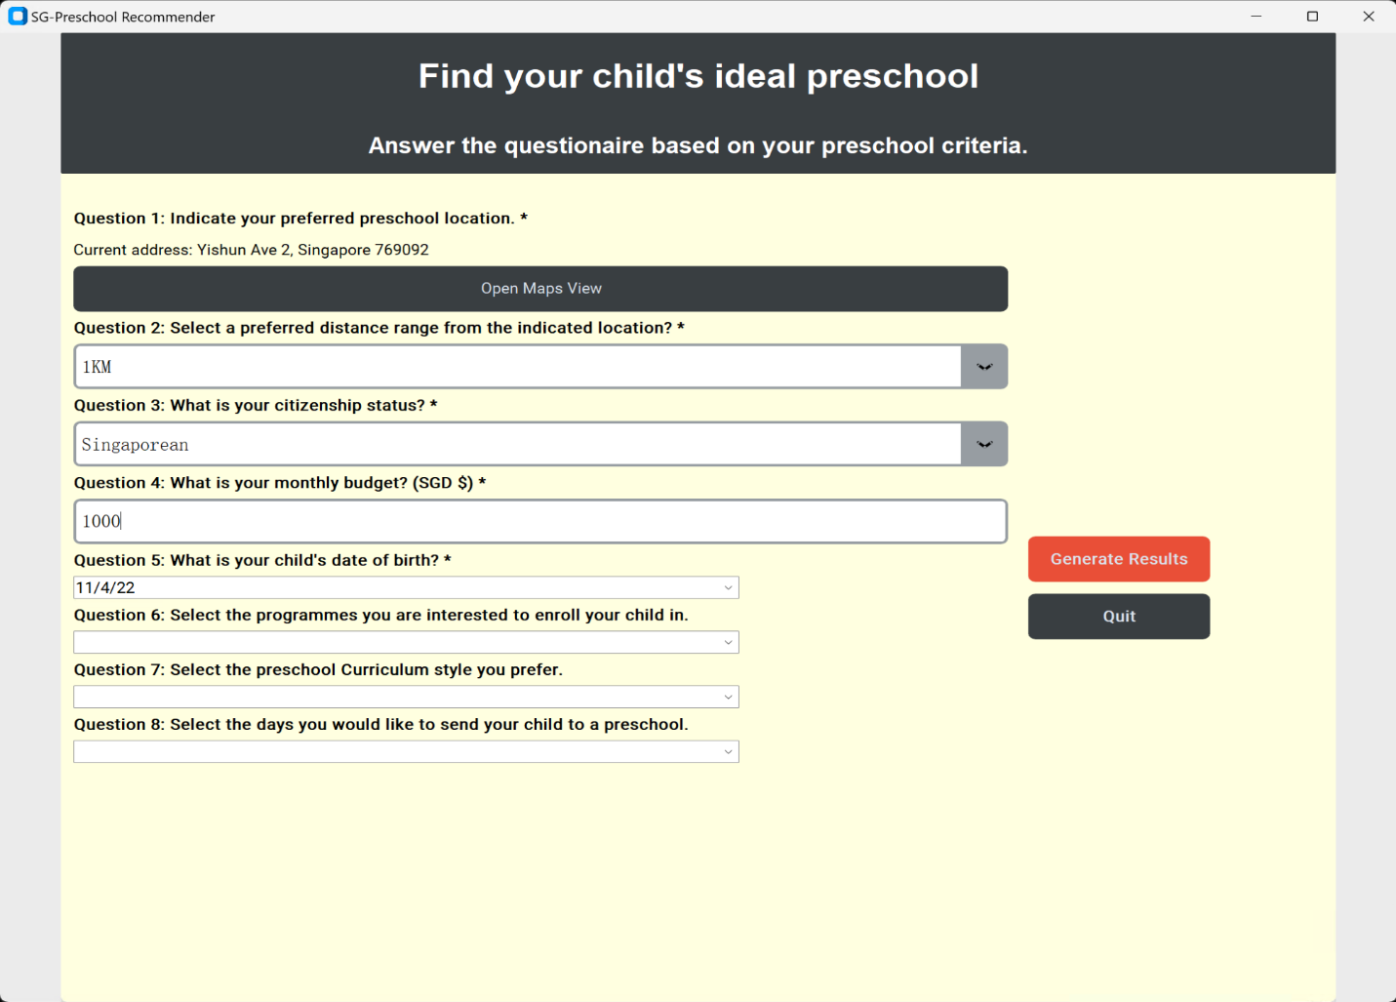

Once user click Generate Results button, the below results page will show. It will return the top 3 preschool of 3 different brands with the closest match to the user input. User can click the tab on top to switch to different preschools to view more details about each school.

Each tab will display the school’s name, school address, school website link and a map with its location marked. Users can click and drag the map to look around the school area. For more detailed information about the school, users can click on the link provided. This will open a new browser tab to the school’s official website.

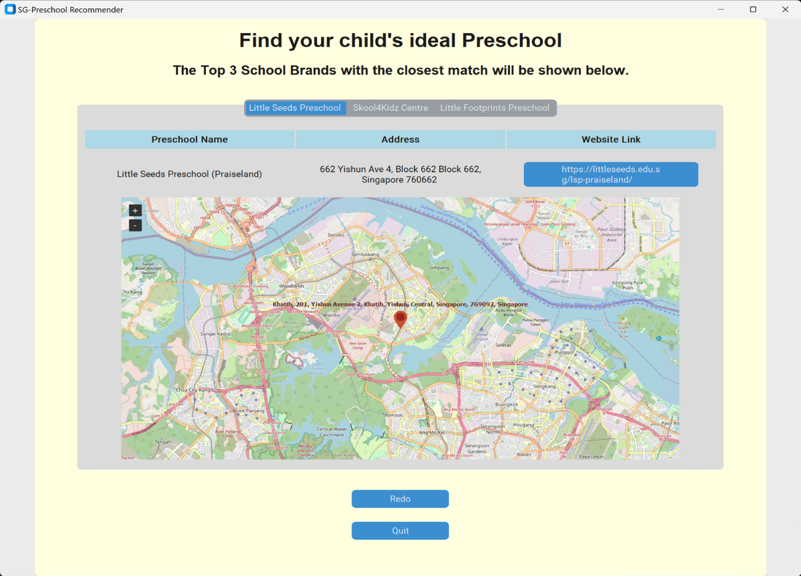

If the results given are not satisfactory, user can click the “Redo” button and re-submit a new set of input criteria. Some combination of user inputs would not return any matching preschools. The results will instead display an empty “Preschool 1” with a message indicating that there are no schools matching the inputs provided. Users should return to redo the questions with a new set of preschool criteria.

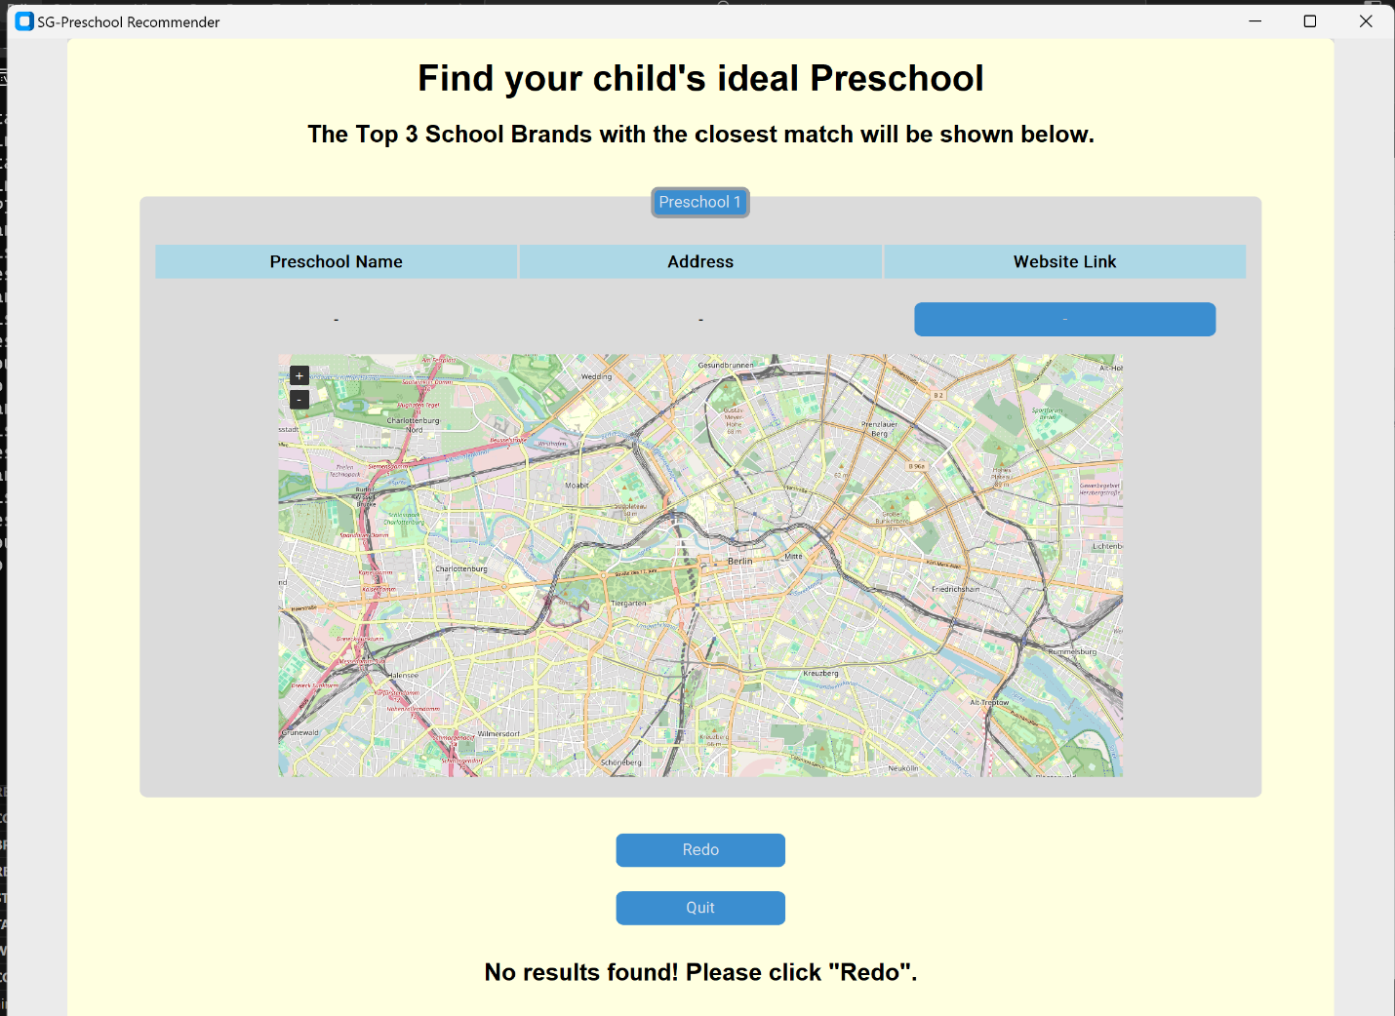

Once the user is satisfied with results, the “Quit” button will close the application.

### Exploring Preschool Options

#### Searching in a different area

User can select their location by clicking the “Open Maps View” button on the starting page. A map window will popup, featuring the Singapore Map.

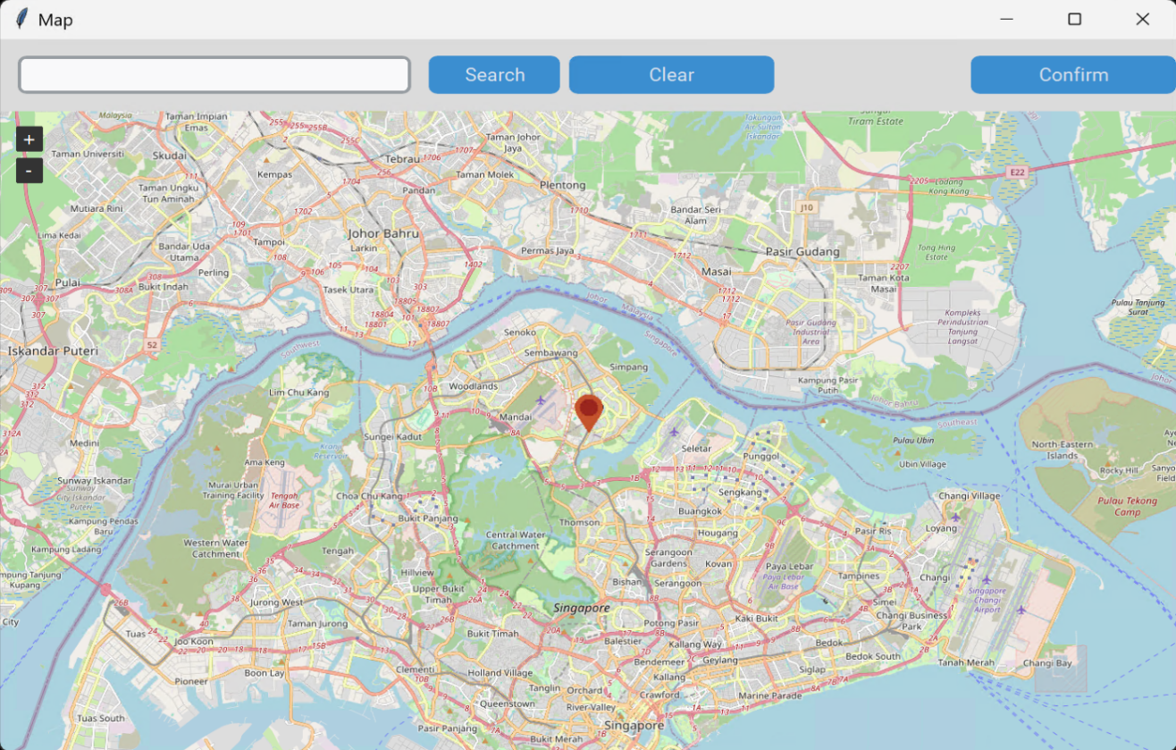

Default Maps View

Users can easily drag with their mouse to navigate around the map. The map also features a set of buttons on the top right to zoom in or zoom out of the map. Similarly, users can use their mouse wheel button to zoom in or out. We have provided the user with two intuitive methods to mark their preferred Preschool location.

The first method allows the user to search a location using the Search Bar. The preferred search input for this method is using postal codes. User can click the “Search” button to jump to the postal code location. The search function will also automatically set a Marker for the user as an indicator for their preferred Preschool location. Users may also use their Address Street as search terms.

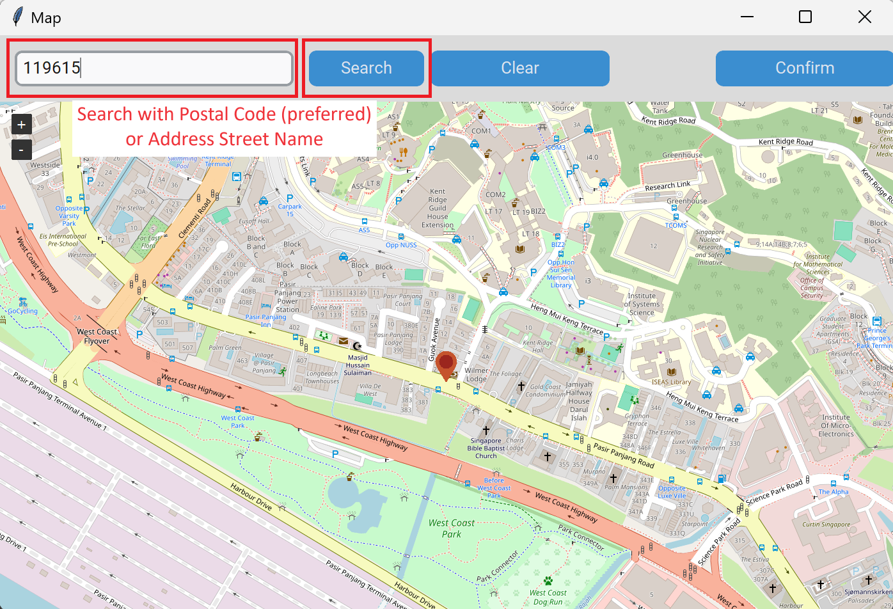

Postal Code search for NUS ISS

The second method allows the user to simply place a Marker on the map with a simple Left-Click on their mouse. Clicking on the map will automatically set a Marker for the user at the location. Users are allowed to click on another location to reset the position of the Marker.

Only one marker will be allowed to be placed on the map at any point. Users can use the “Clear” button to remove the marker placed or replace the old marker with a new marker using the two existing methods mentioned.

Once the location has been selected, the user can use the “Confirm” button to exit the “Maps View” option or simply close the window.

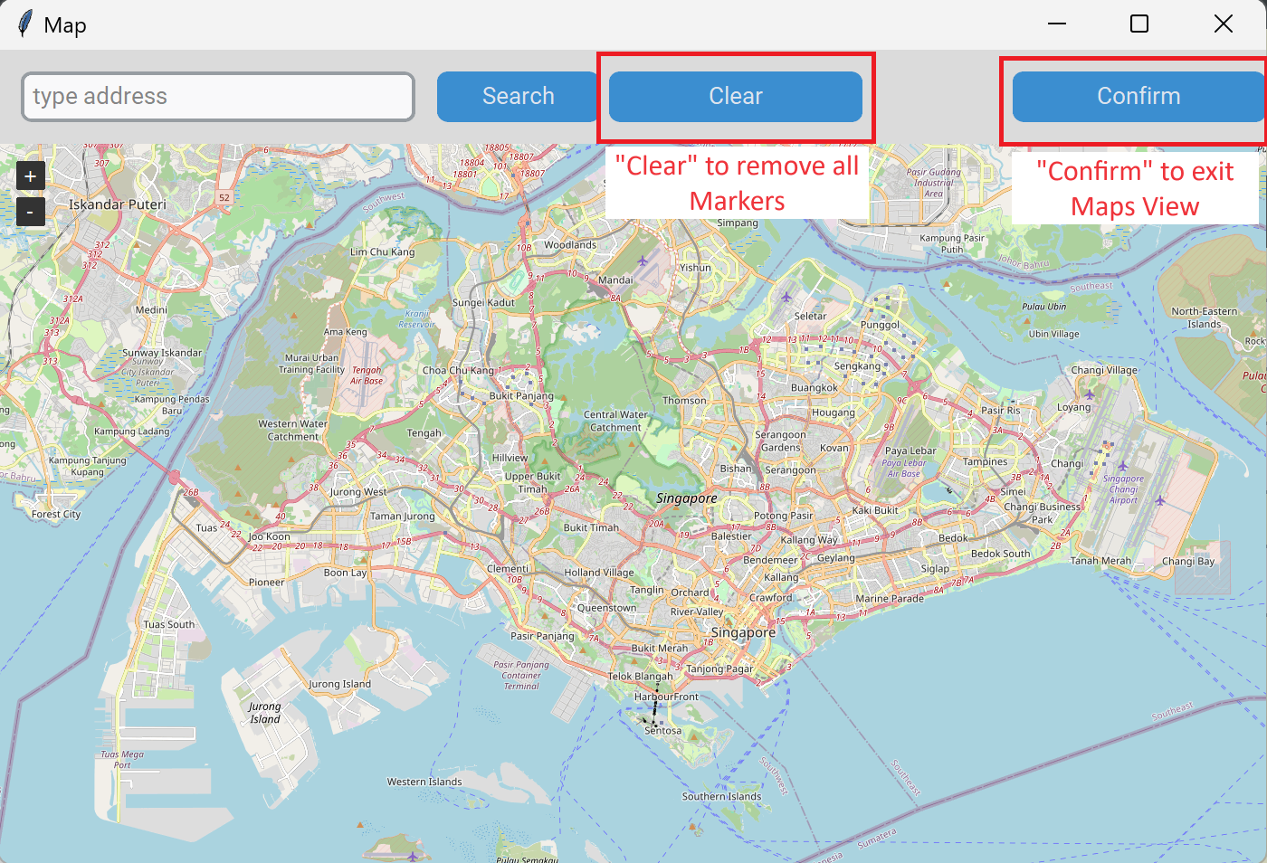

#### Inputting user filter preferences

For preferred distance, citizenship status, child’s date of birth, programs to enrol your child in, preschool curriculum style and the days send child to school, system provides several options as shown in below. If user choose the days send their child to school, an additional question about pick-up and drop-off timing will show. User has flexibility to choose what they think most fit for their requirements.

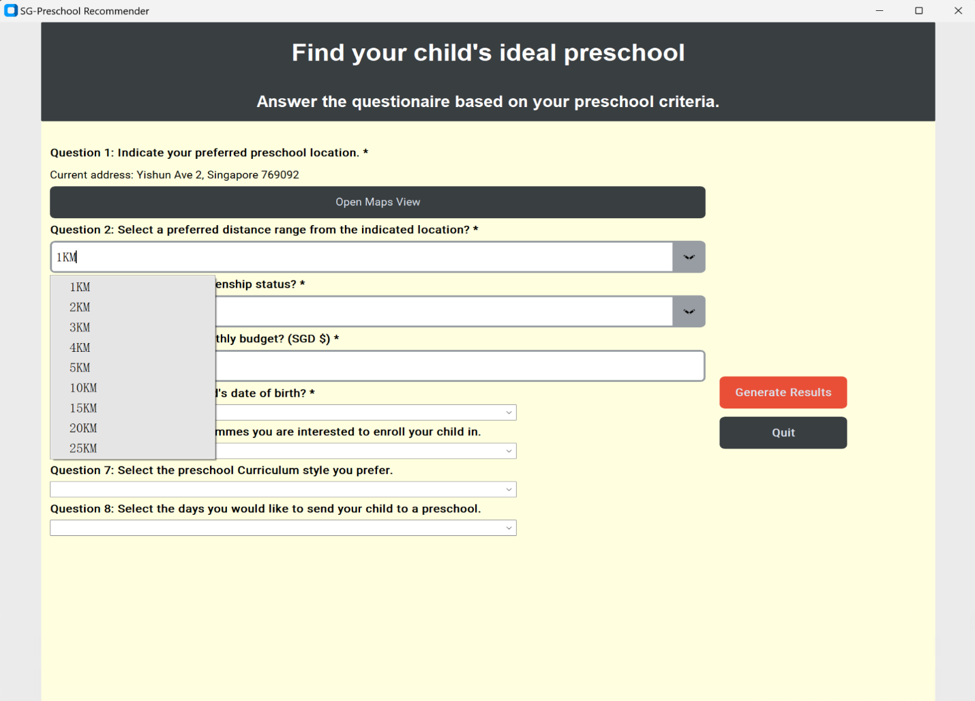Fig1. Preferred distance option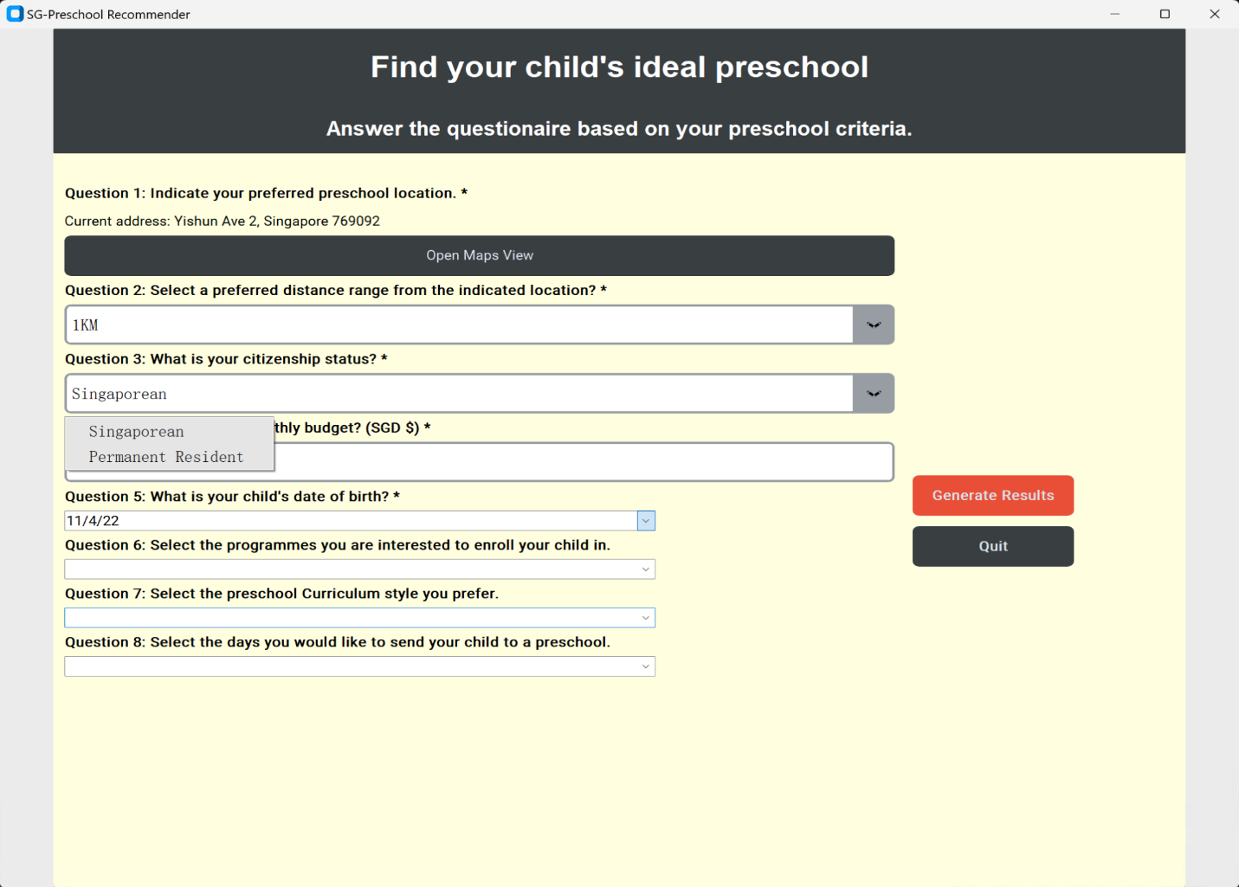Fig2. Citizenship status option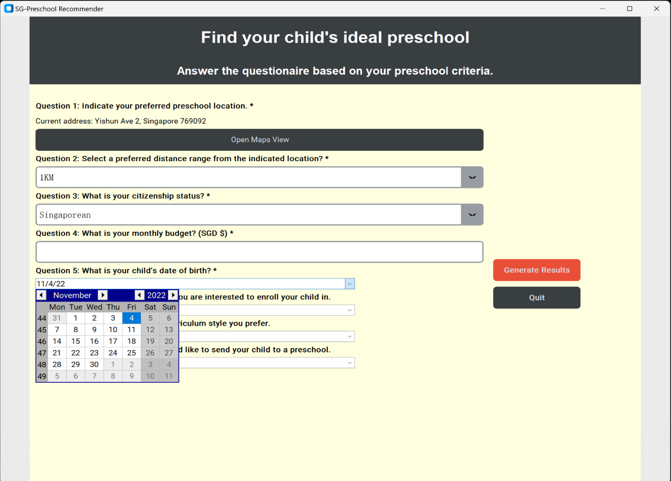Fig3. Child’s data of birth, the default value is set to 18 months ago from the date that system runs 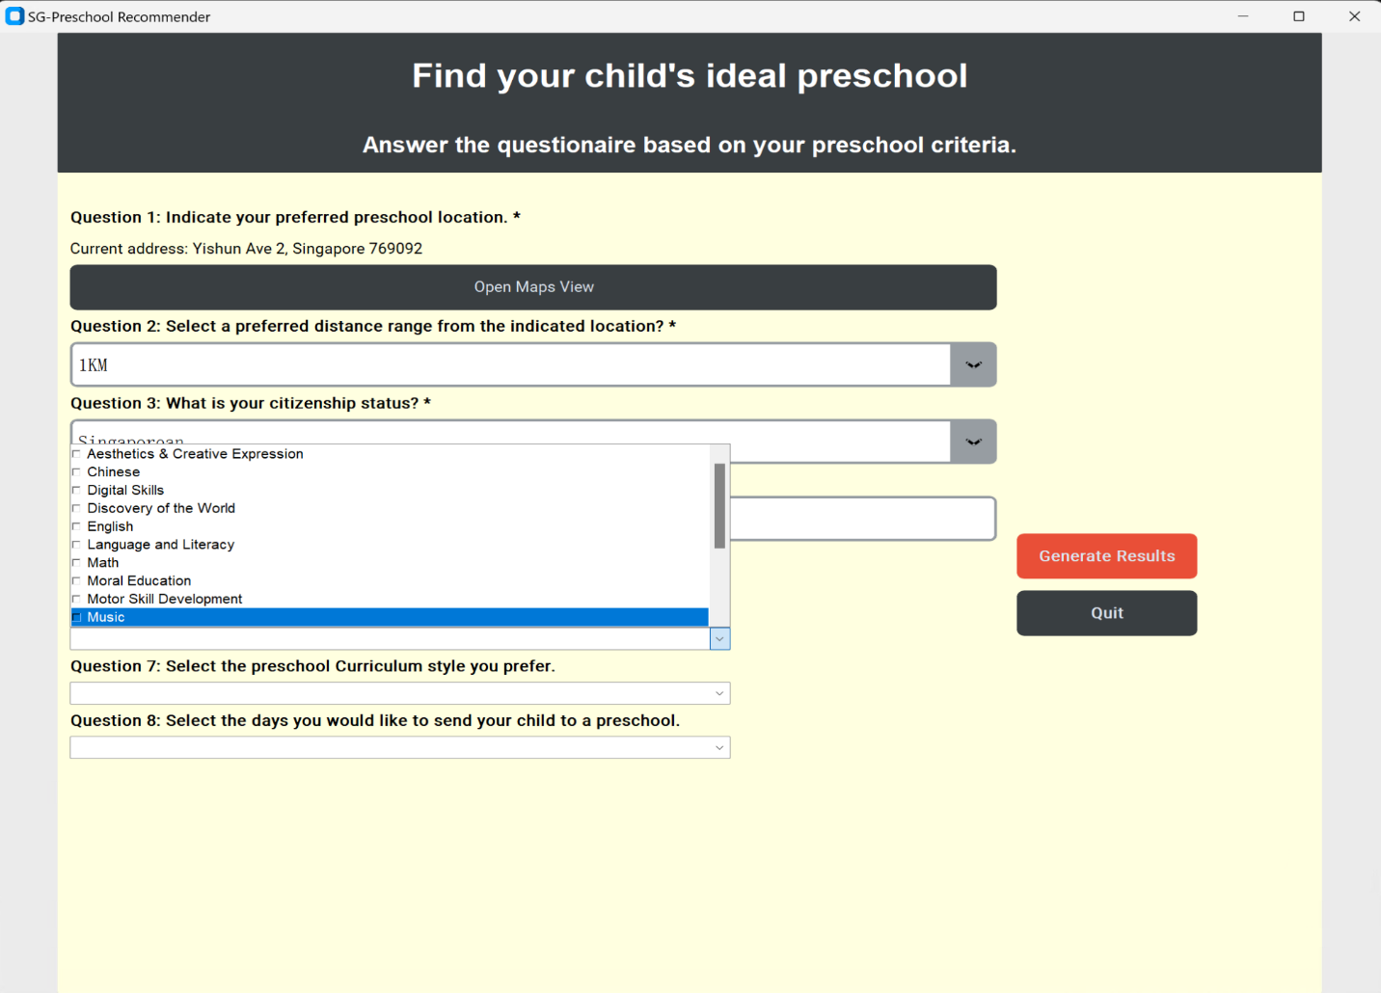Fig4. Programs that child interested to enrol in

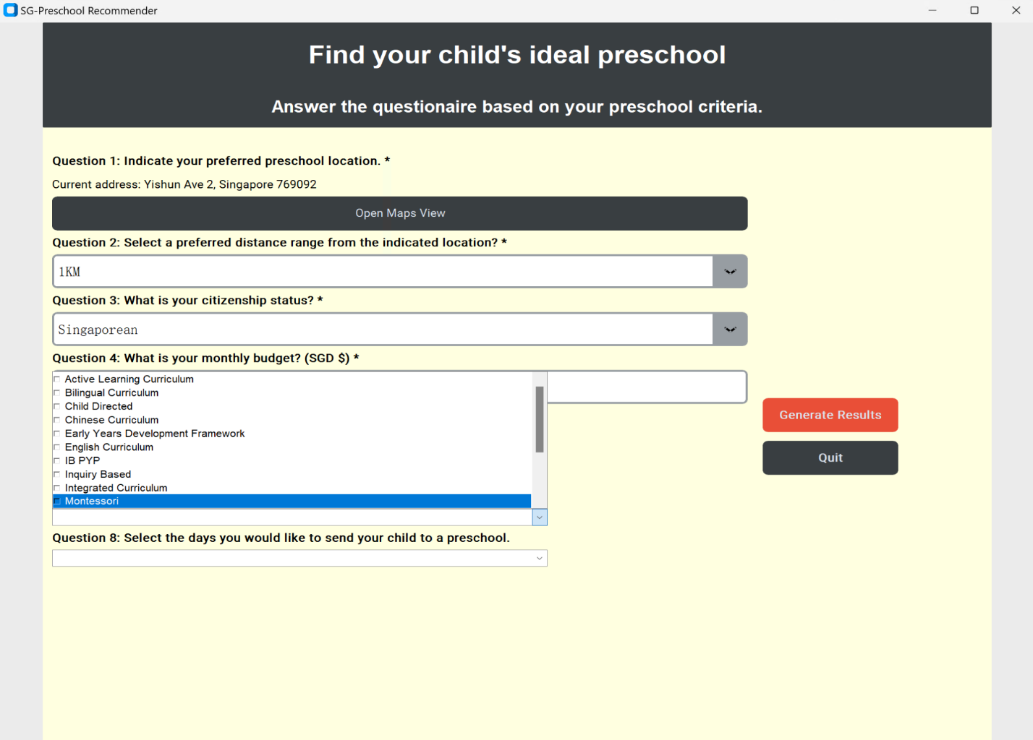Fig5. Preferred preschool curriculum

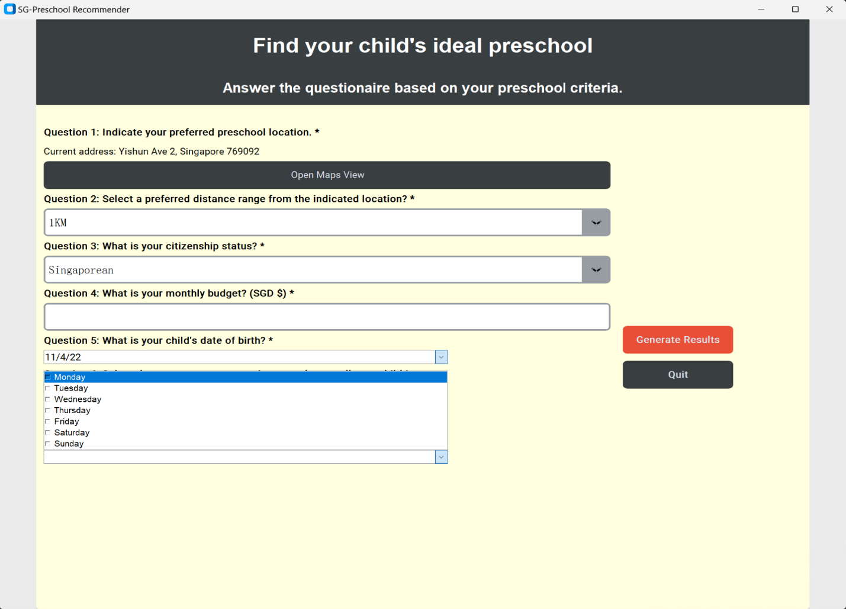Fig6. Days that would send child to

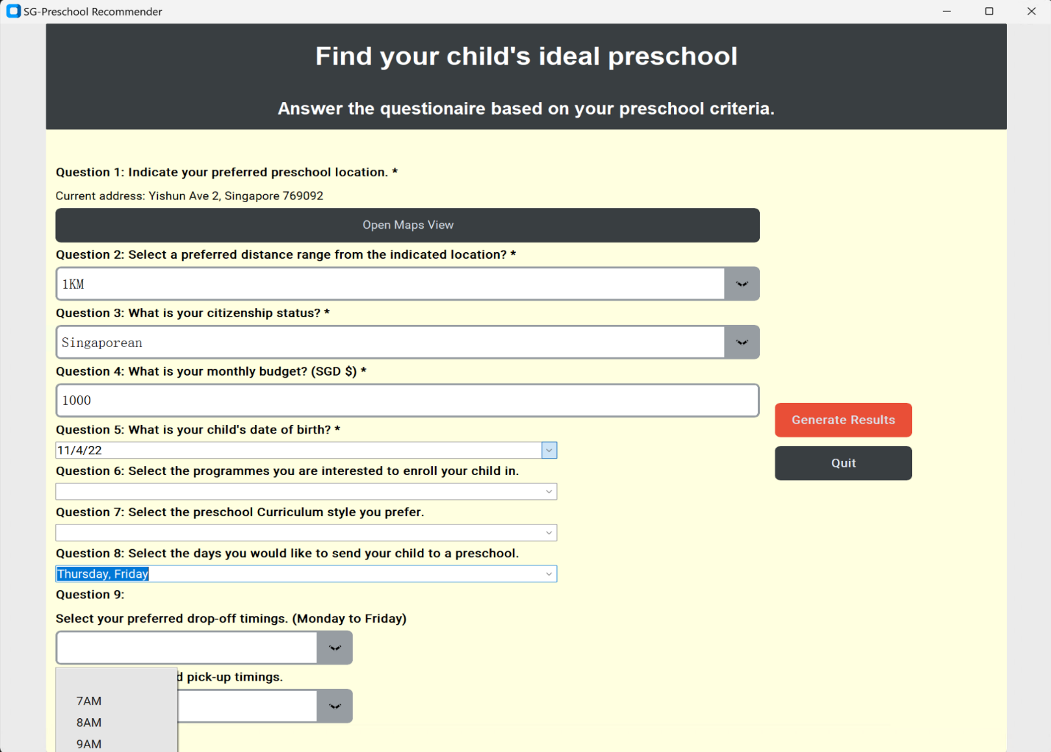Fig7. Preferred drop-off timings.

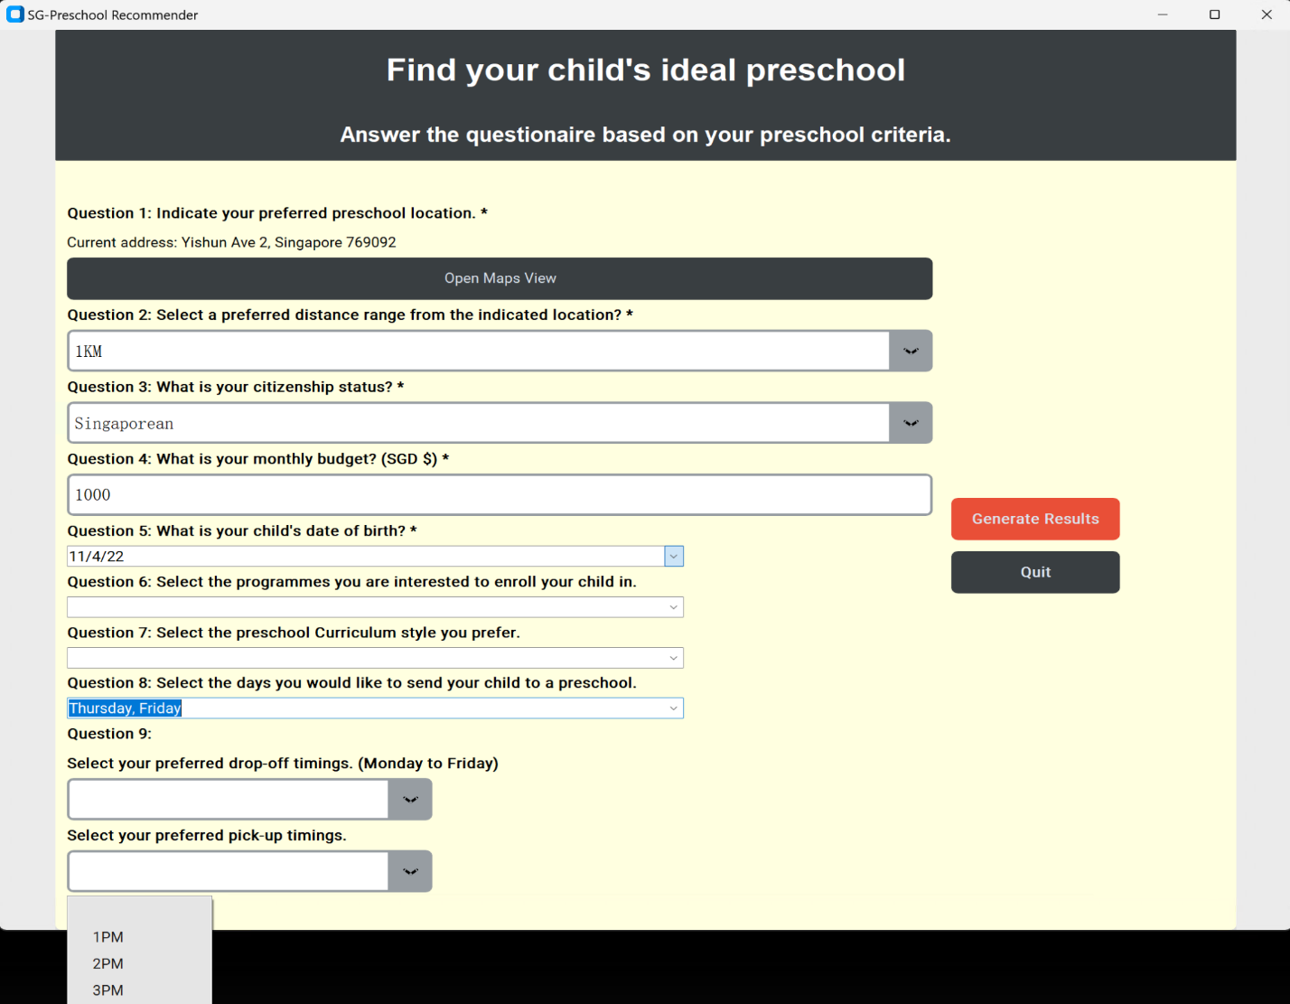Fig8. Preferred pick-up timings.

#### User access options (computer etc).

This MVP currently can only run on Windows operation system. Internet access is required for location selection.

#### Frequently Asked Questions (FAQs)

* Q1: Can this system be used for infant care school selection?
* A: No, this MVP only covers the preschool recommendation which requires the child is at least 18 months.
* Q2: Does this system have preschools all over world?
* A: No, this MVP only has preschools in Singapore.
* Q3: Does this system cover all preschools in Singapore?
* A: No, this MVP covers most of the preschools in Singapore with some exceptions like religious schools.